NAME: Jinkal Bhatt

Intern student

Report of completion of assigned task by vault tec

**TASK 2**

**Project: Secure Login System with User Role Management**

**Objective**:  
To develop a secure web-based login system incorporating user authentication, authorization, and role-based access control. This project will help you implement key cybersecurity concepts in a development environment while building practical expertise.

DAY 1:

**Project Setup**

* **Setting up for development environment with VS Code and necessary plugins.**

1. python, pylance, git lens, prettier code formatter extensions are installed.

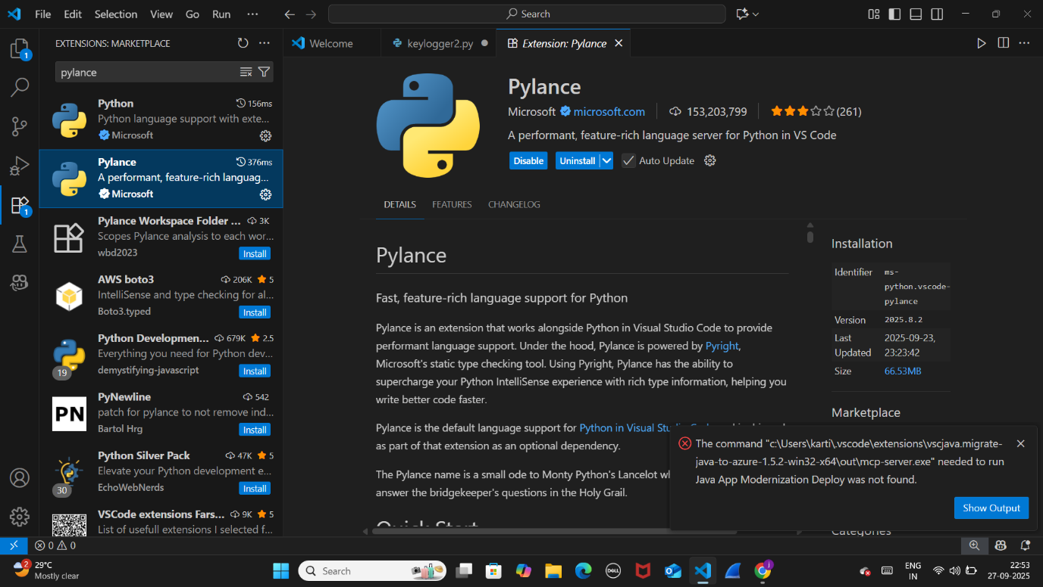

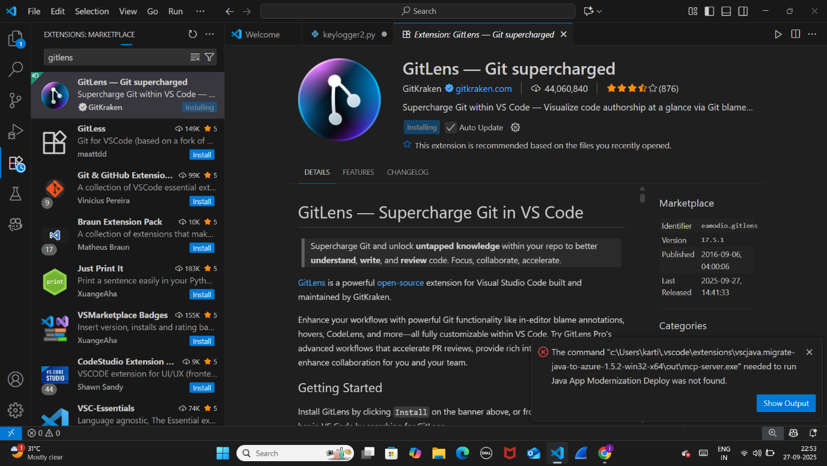

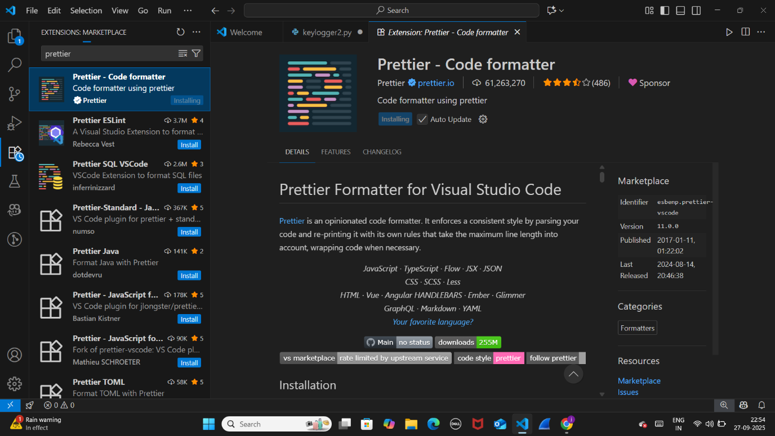

* **Create a GitHub repository for version control.**

**Create repo:**

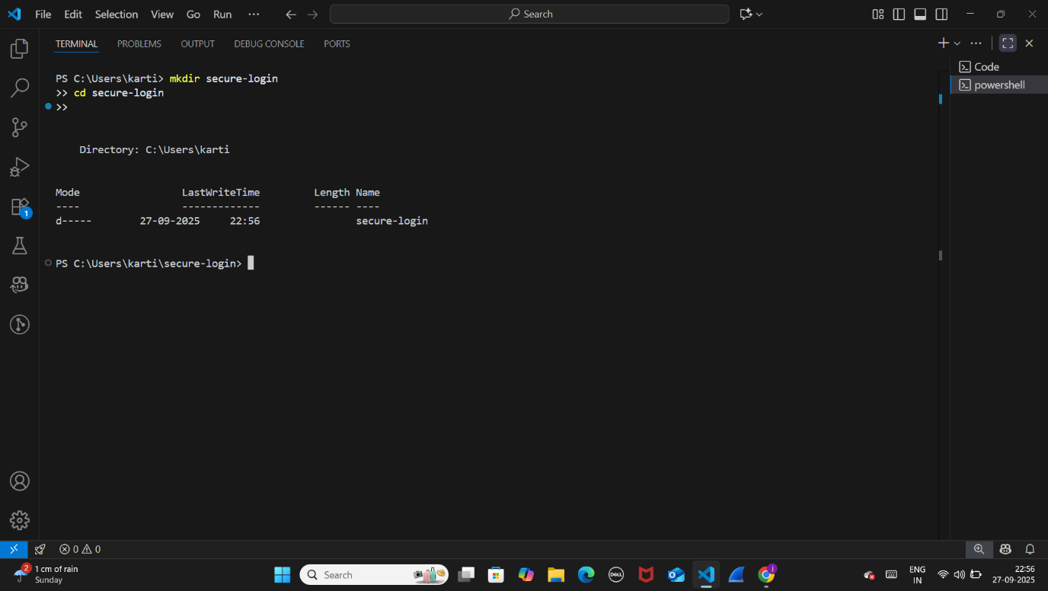

**Virtualenv & requirements:**

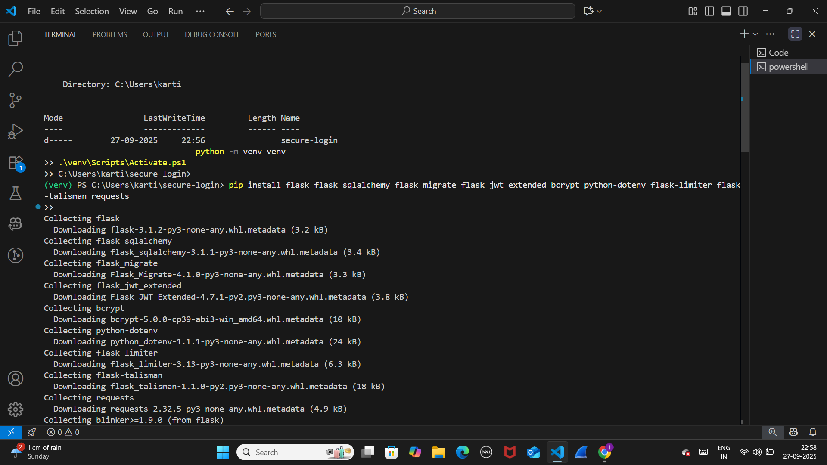

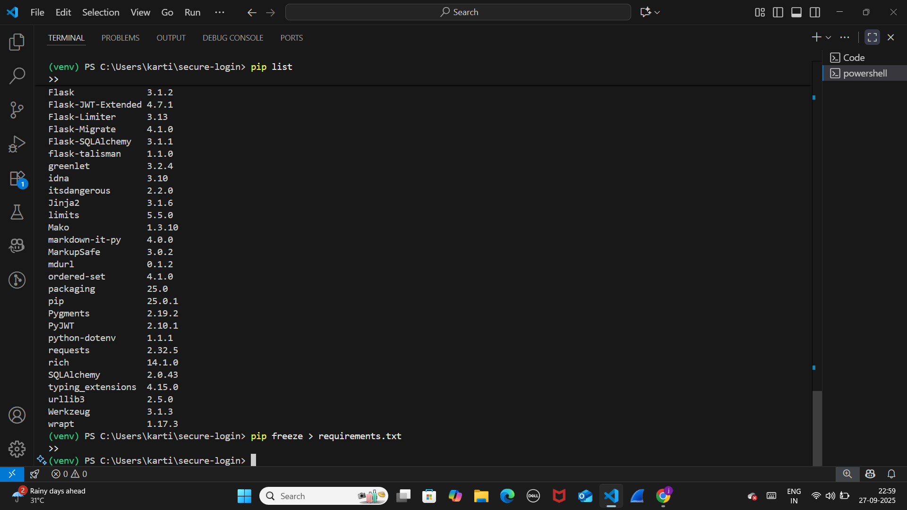

**Create .gitignore :**

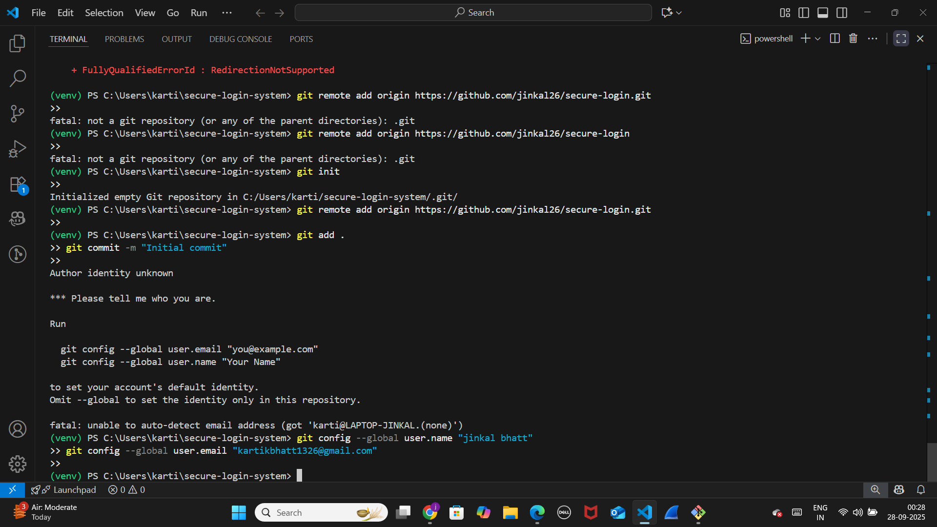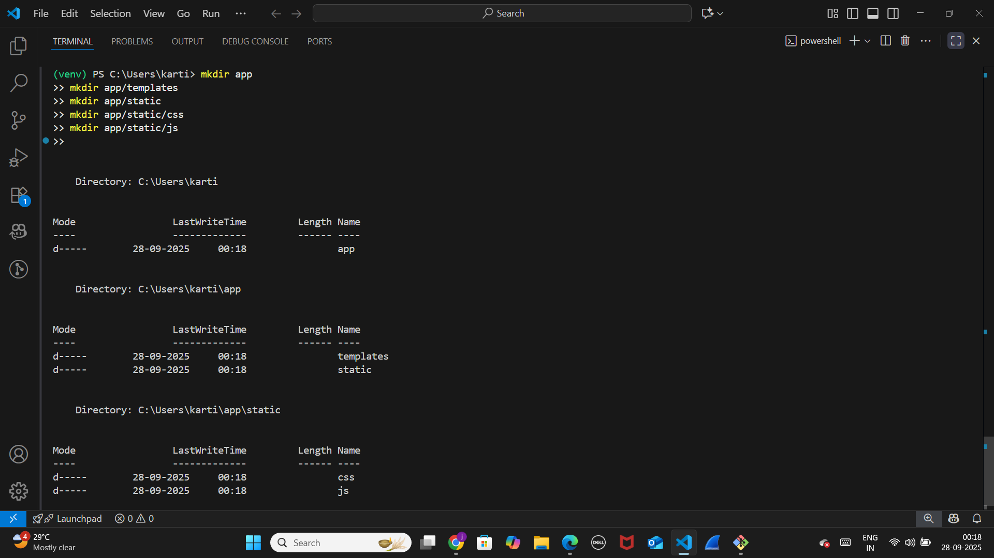

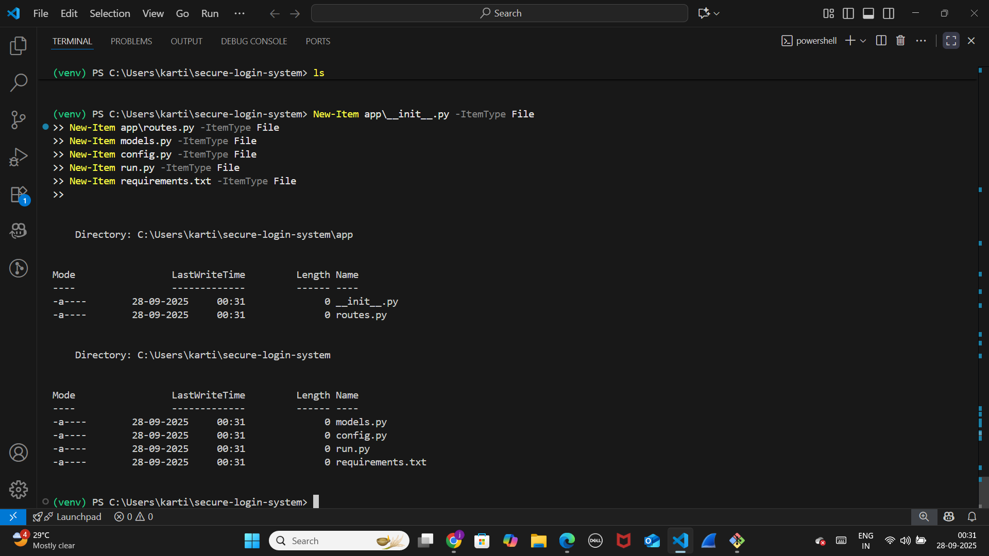

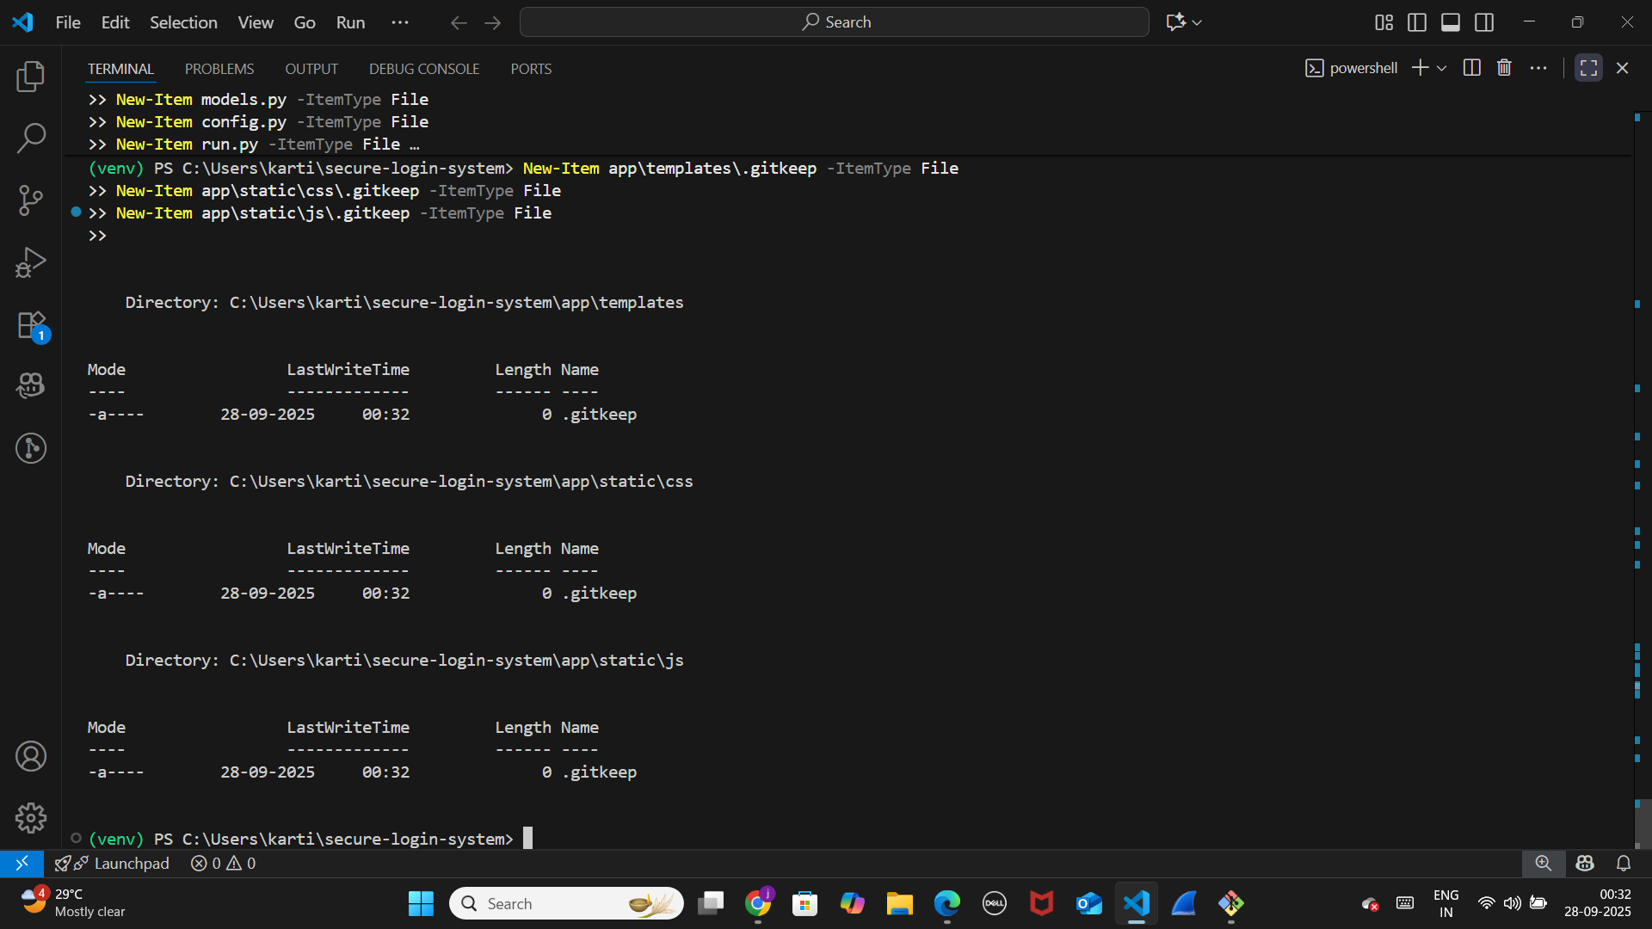

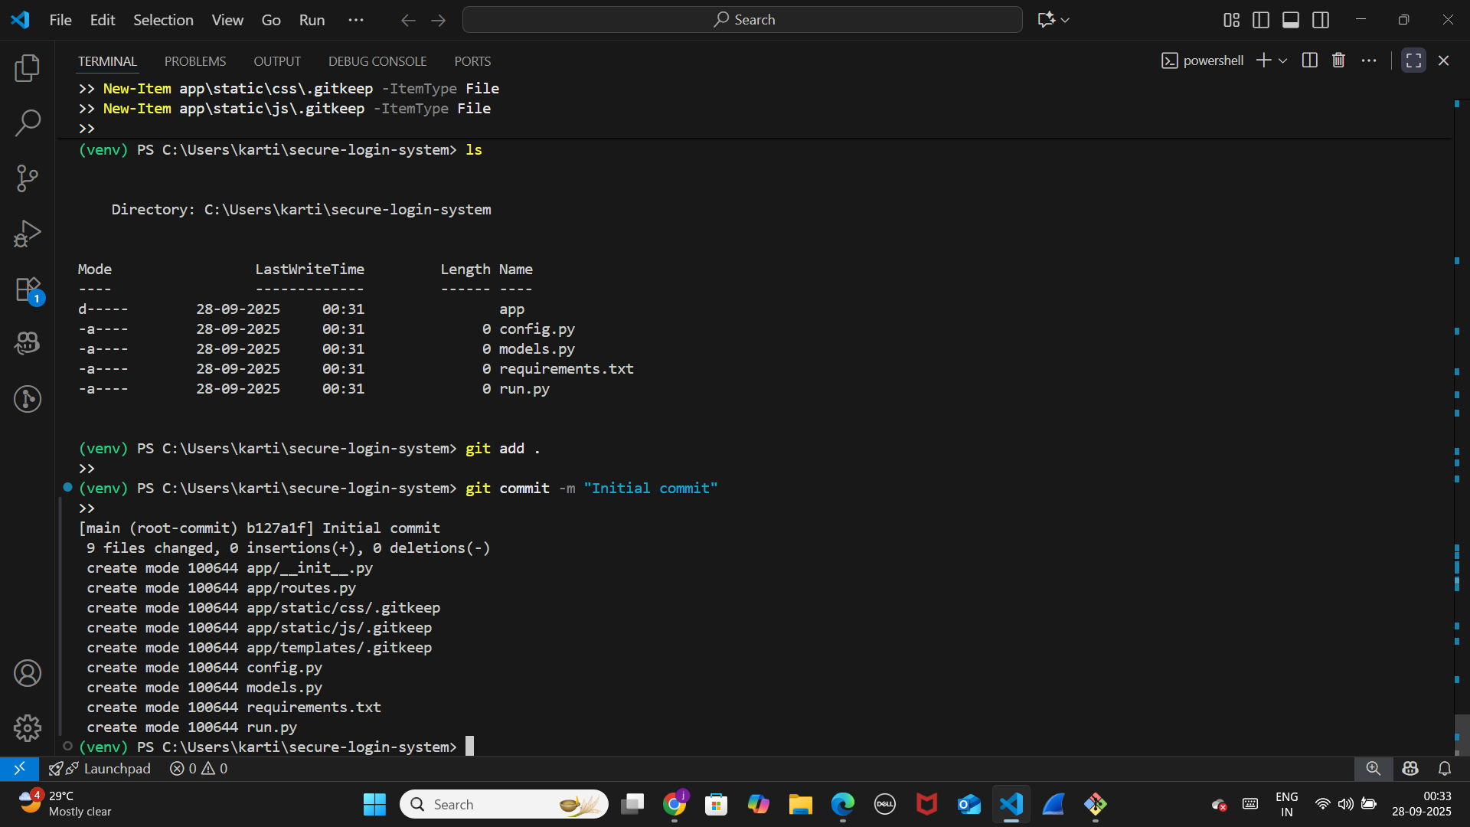

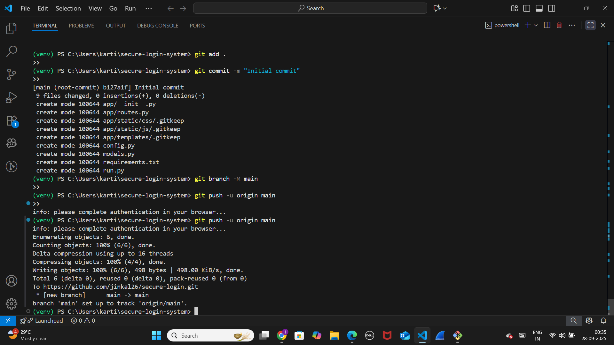

* **Initialize the project with a basic file structure.**

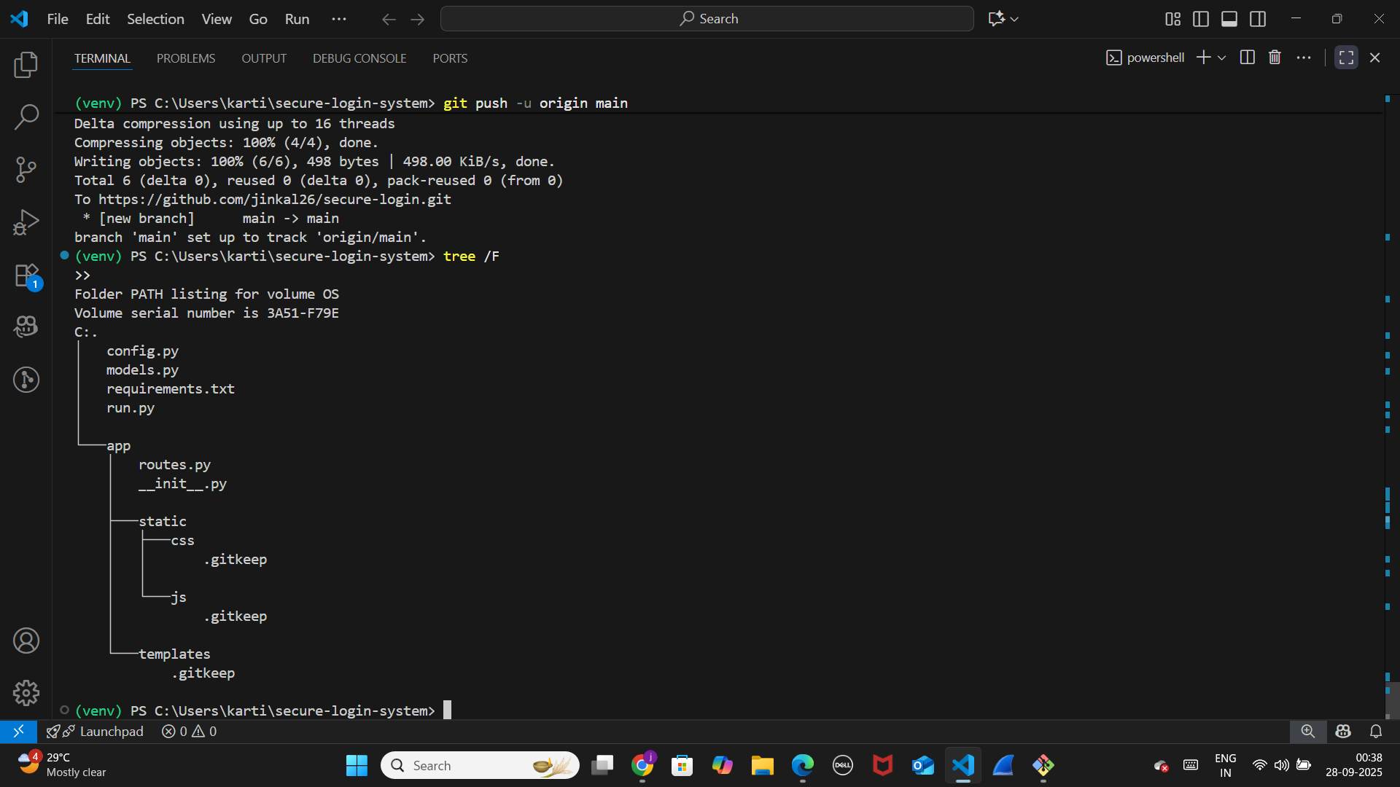

Day 2:

Frontend Development

Registration Page – register.html

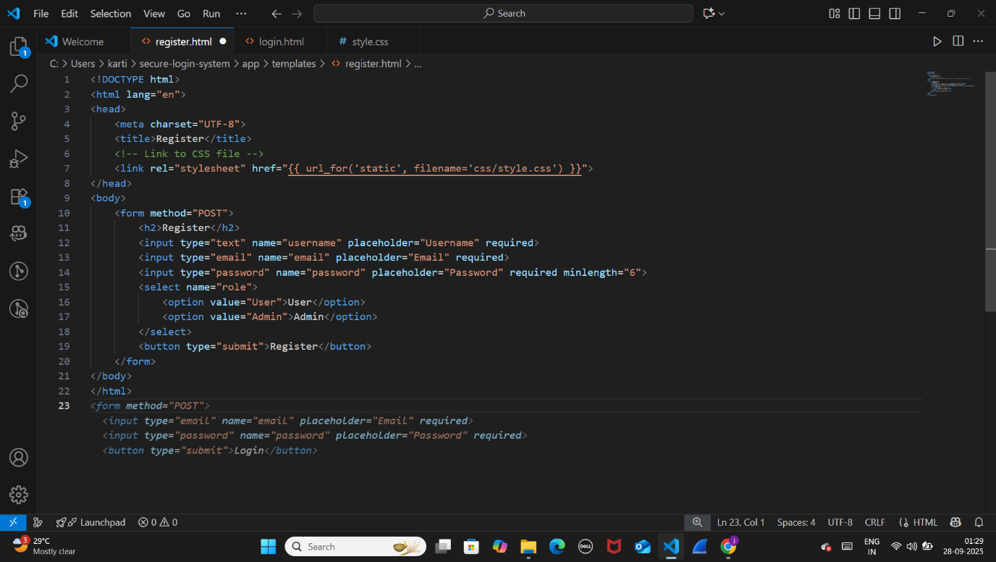

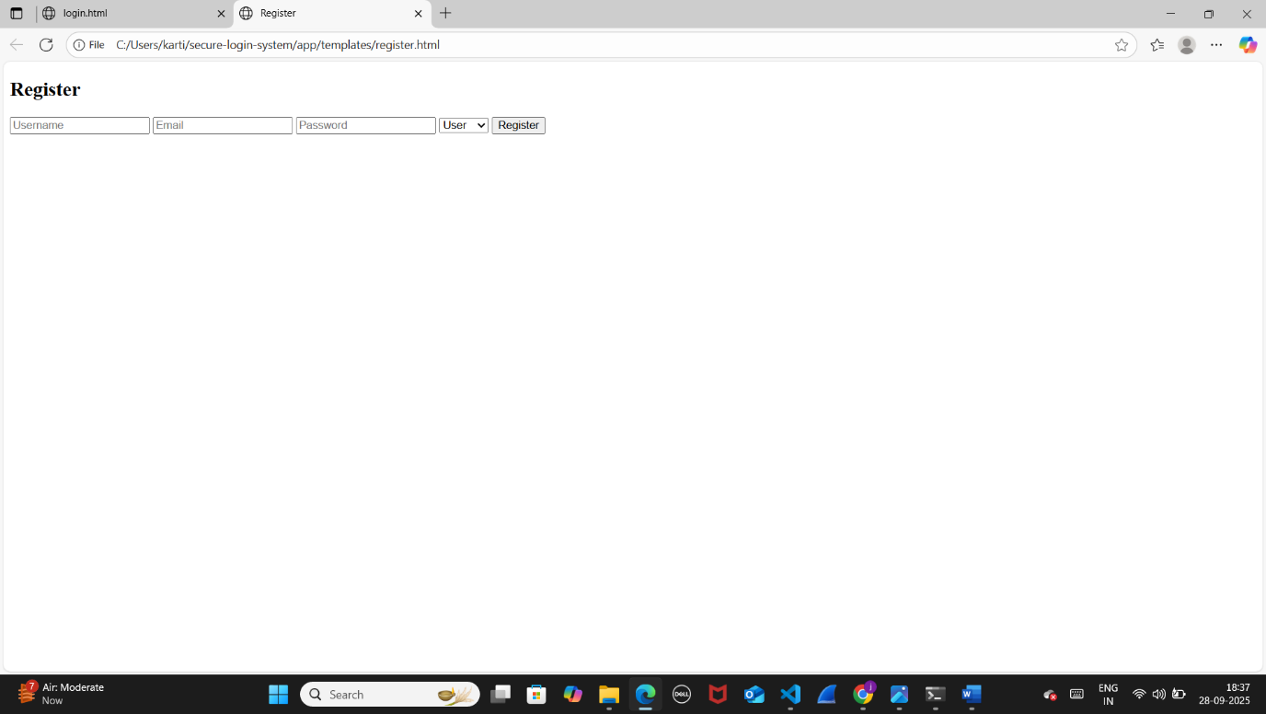

Login Page – login.html

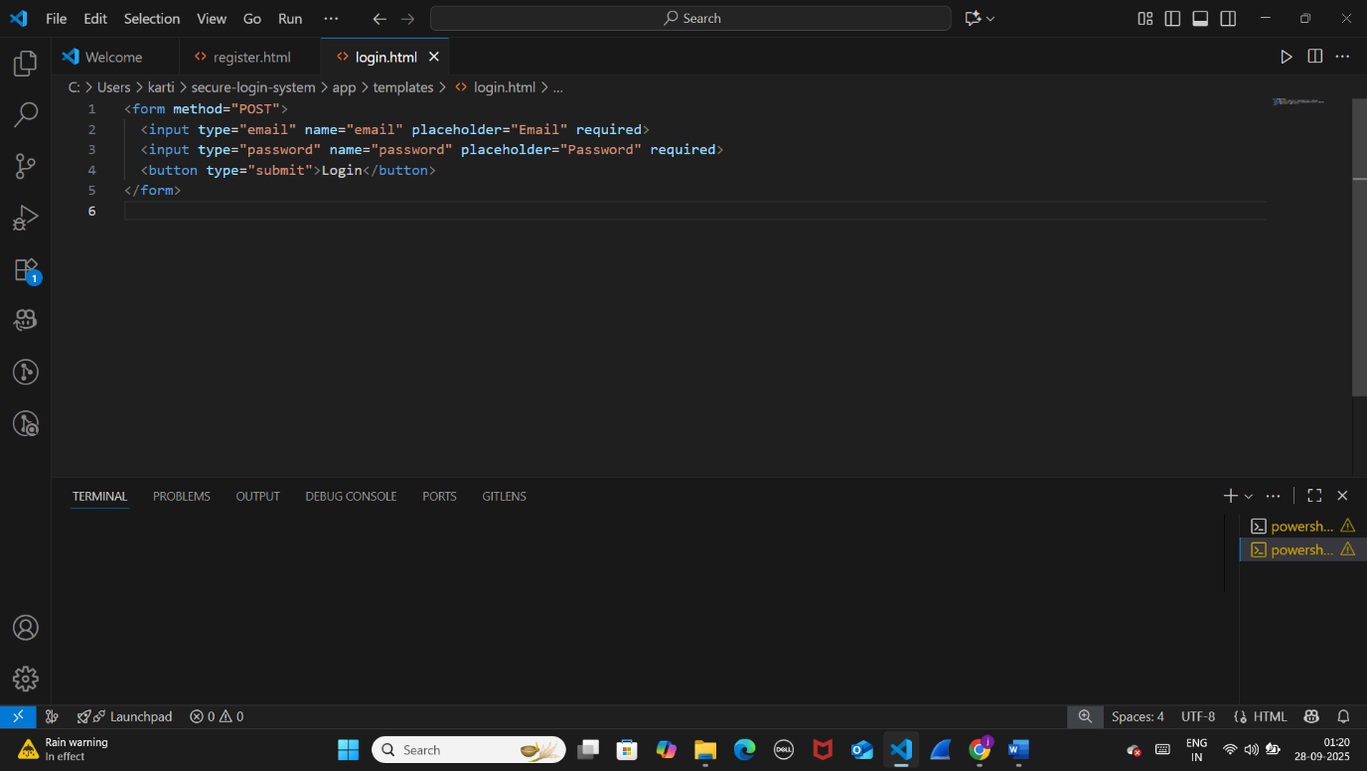

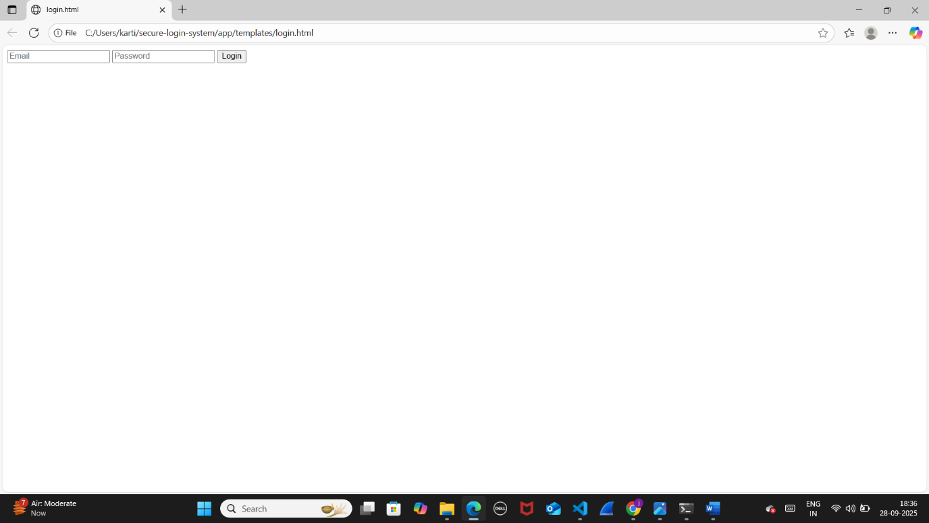

CSS Styling – style.css

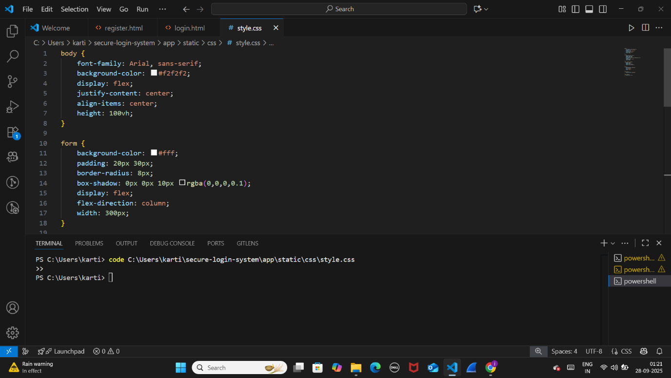

**Day 3:**

**Backend Setup**

* Set up a backend using **Flask** (Python) or **Node.js**.

1. **Set up Flask**

Install Flask and database libraries

pip install Flask Flask-RESTful Flask-SQLAlchemy pymysql

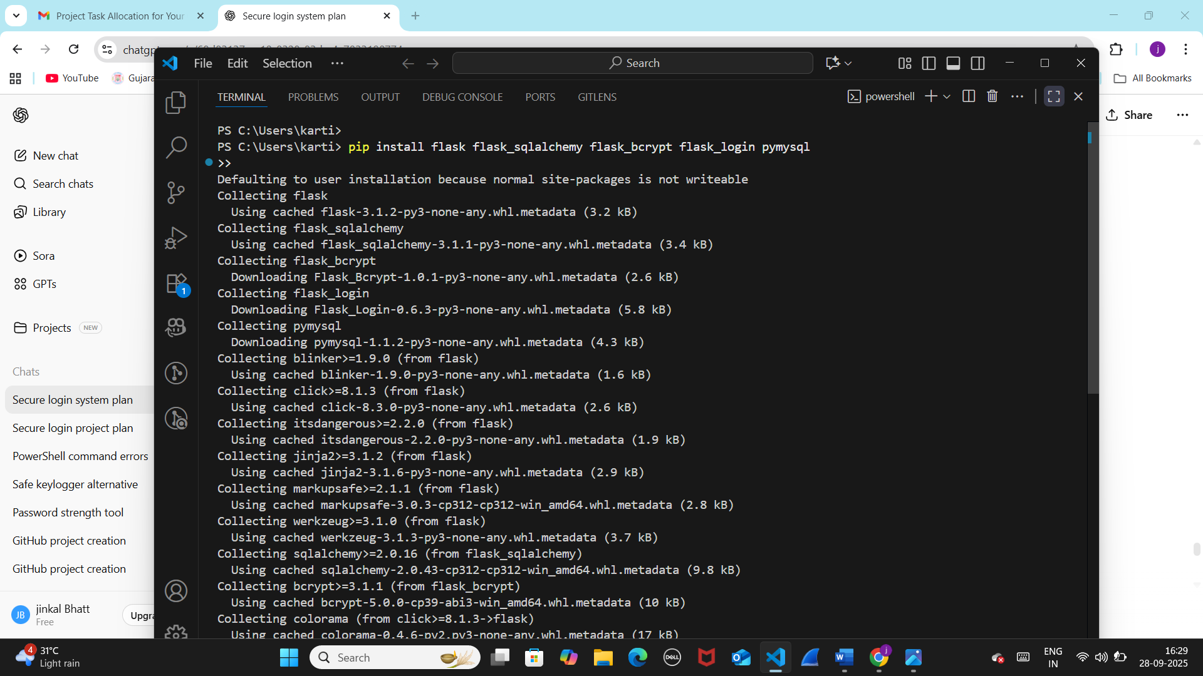

**2.Configure Database (config.py)**

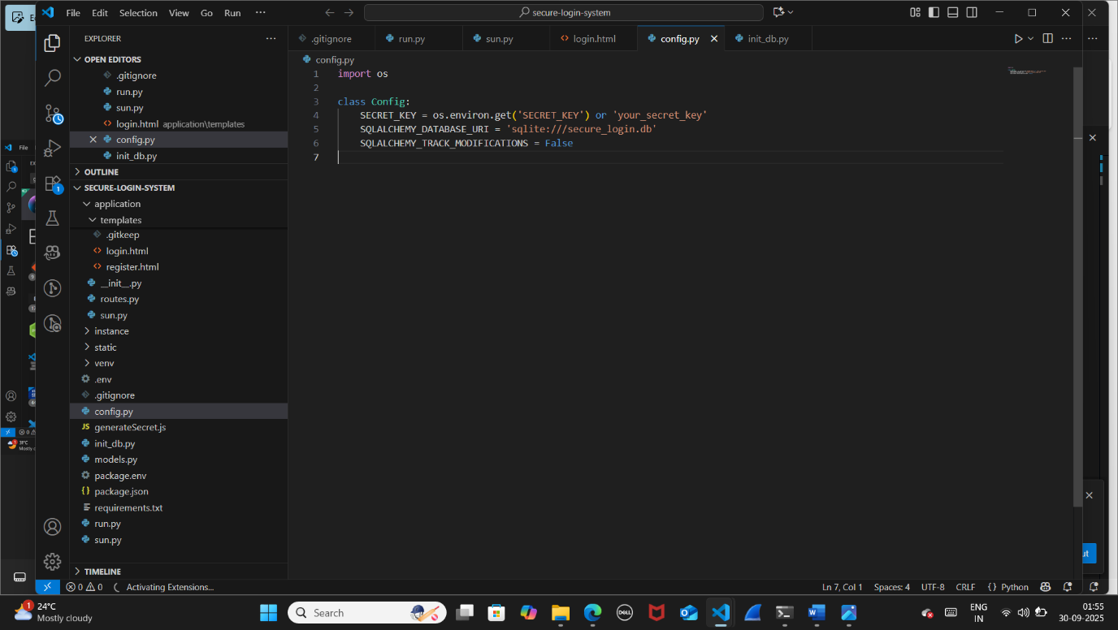

**3.Create Database Models (models.py)**

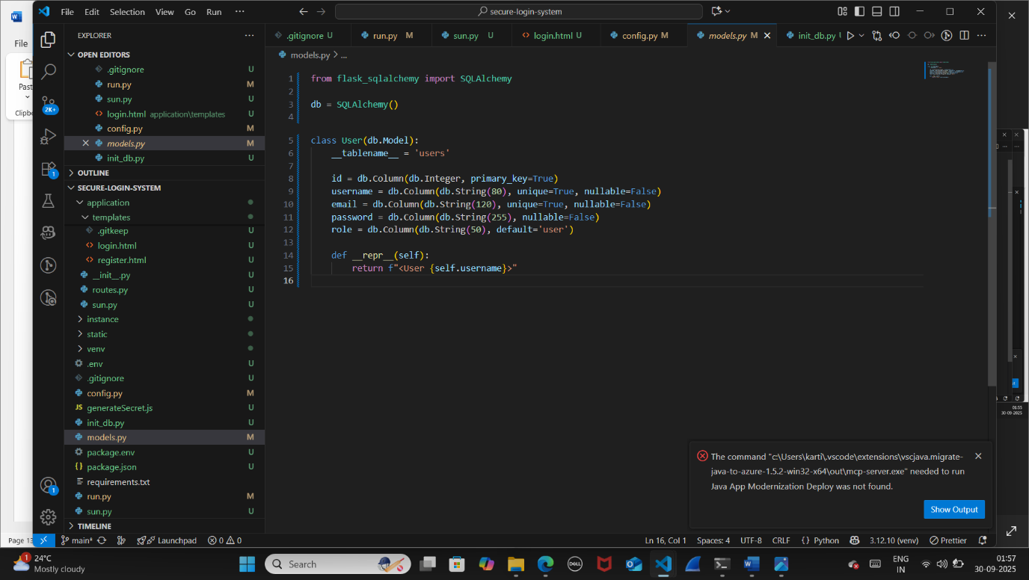

**4.Initialize Flask App (run.py)**

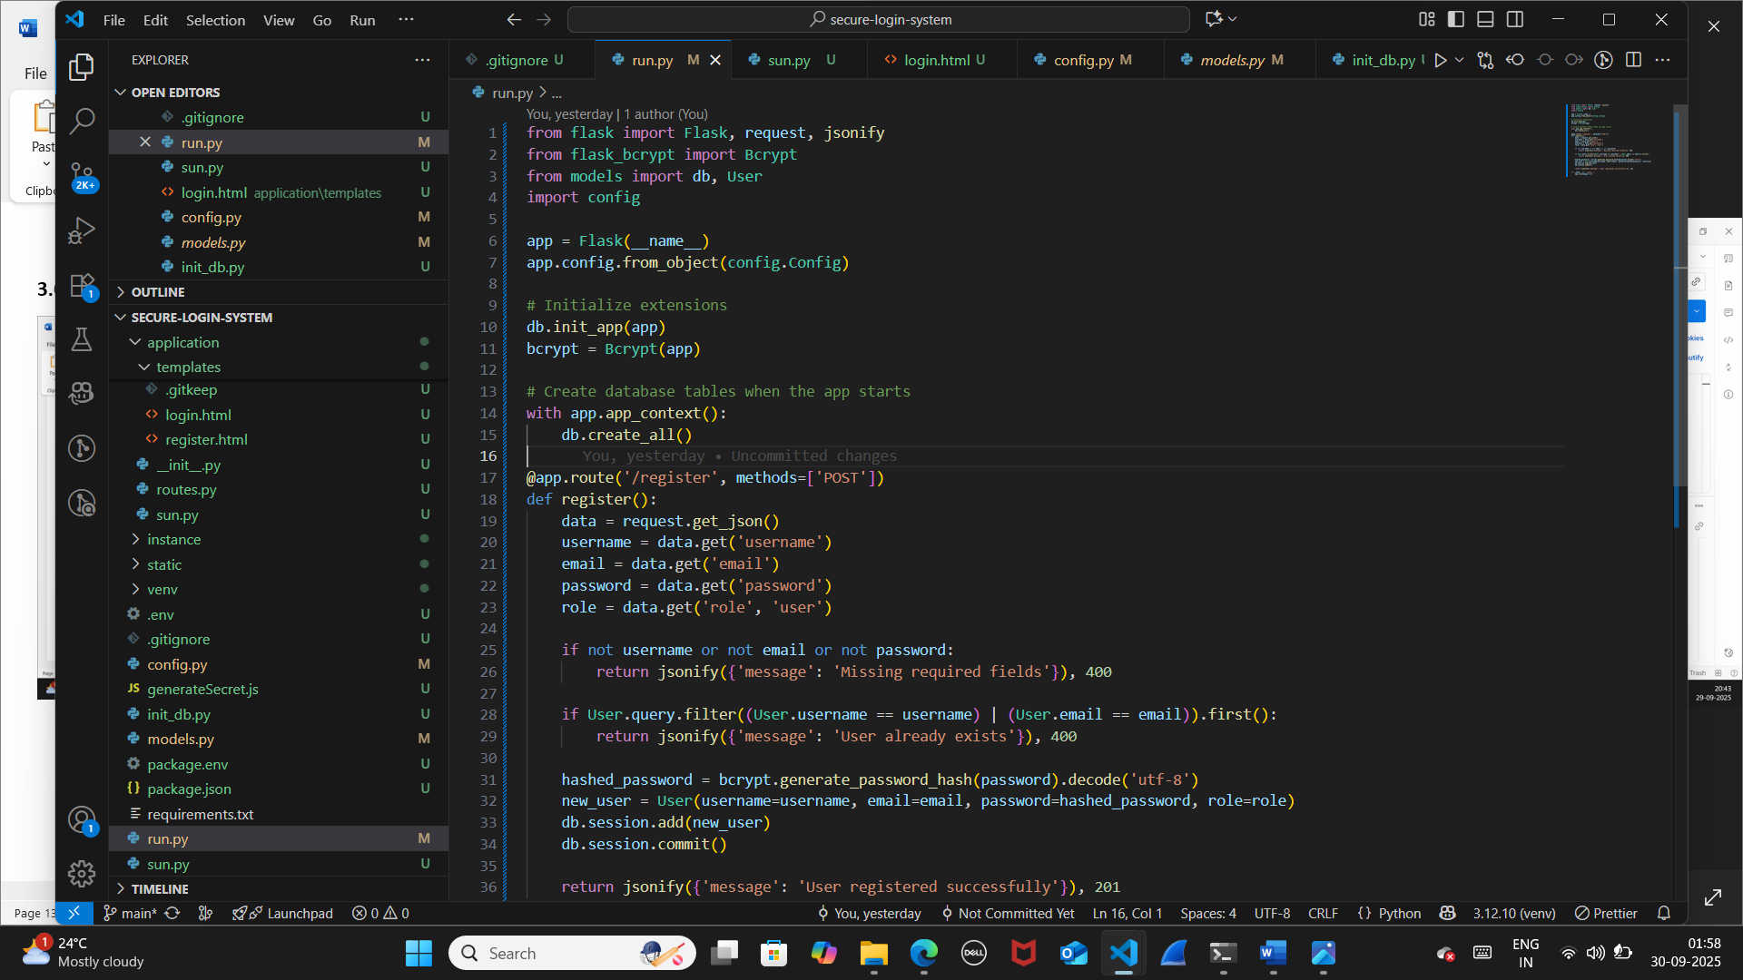

**5.Node.js (Express)**

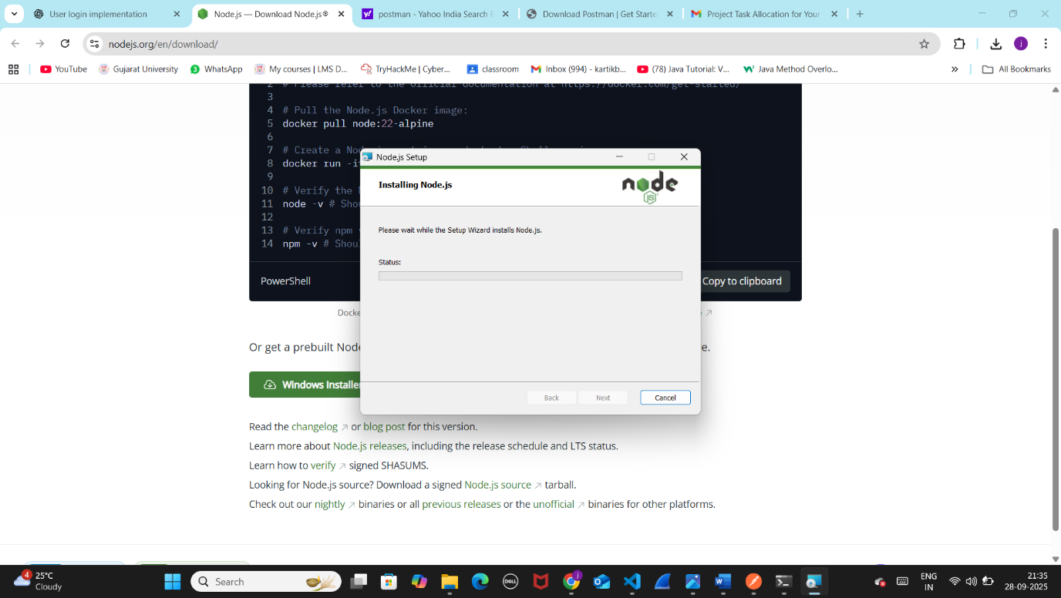

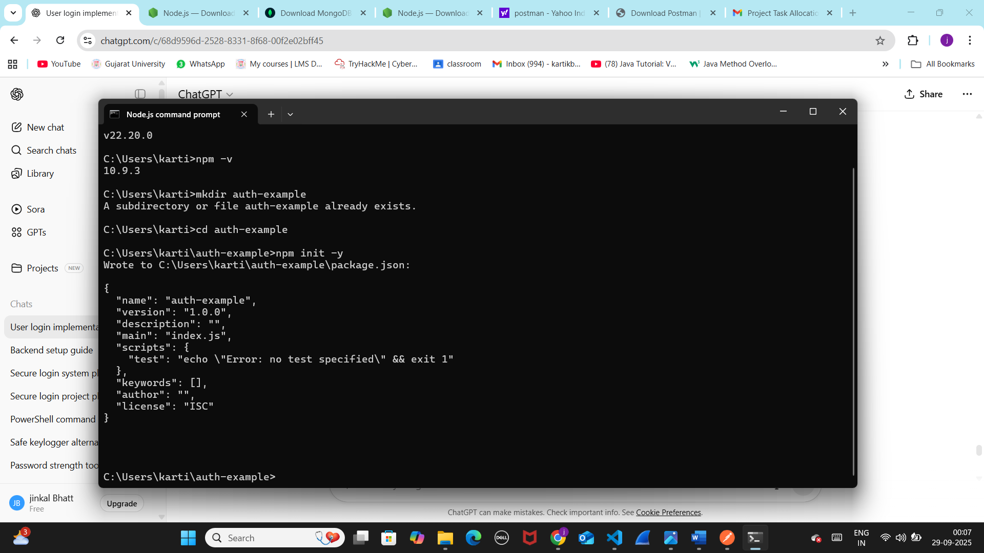

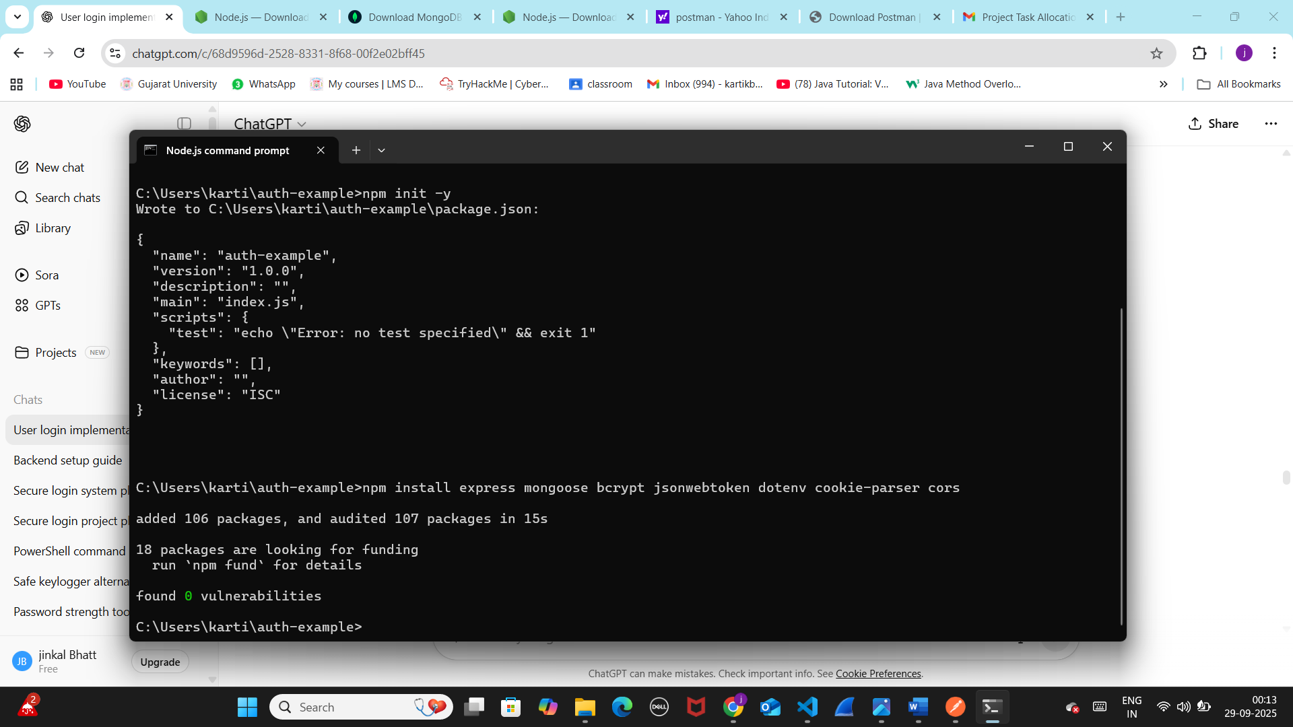

**6.Configure Environment Variables (.env)**

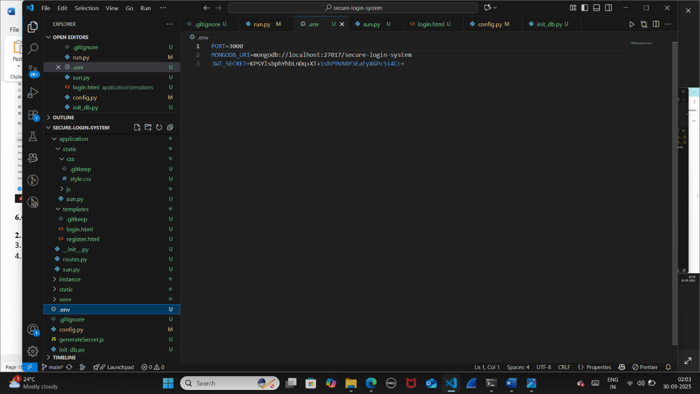

**7.Create User Model (models/User.js)**

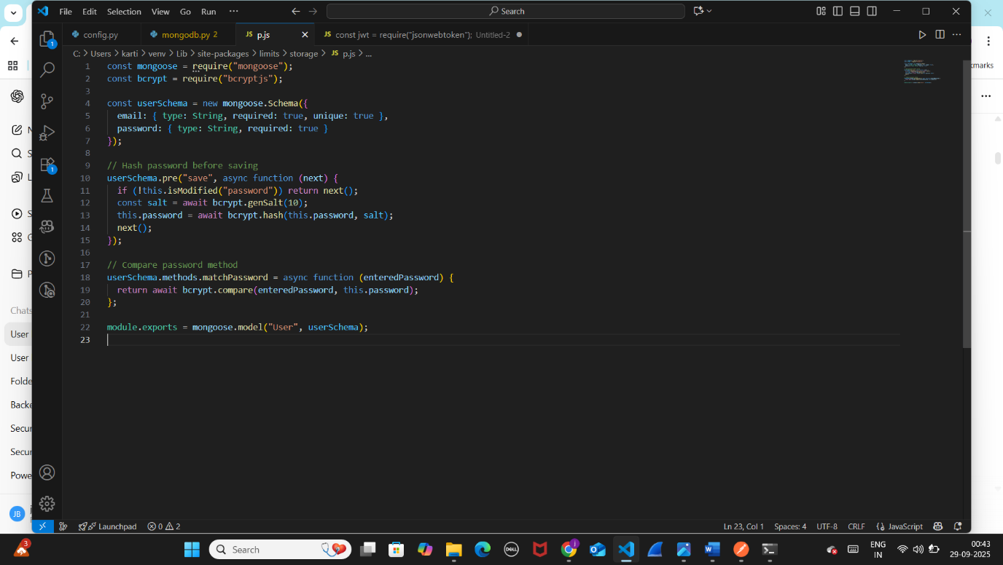

8.Setup Express Server (server.js)

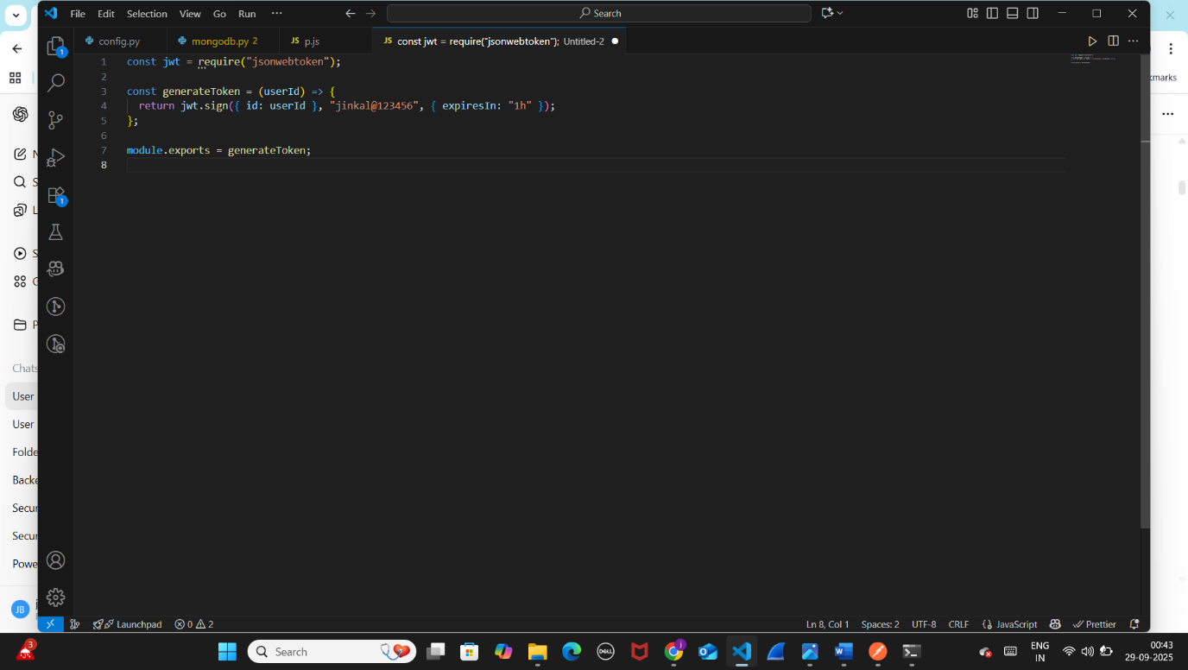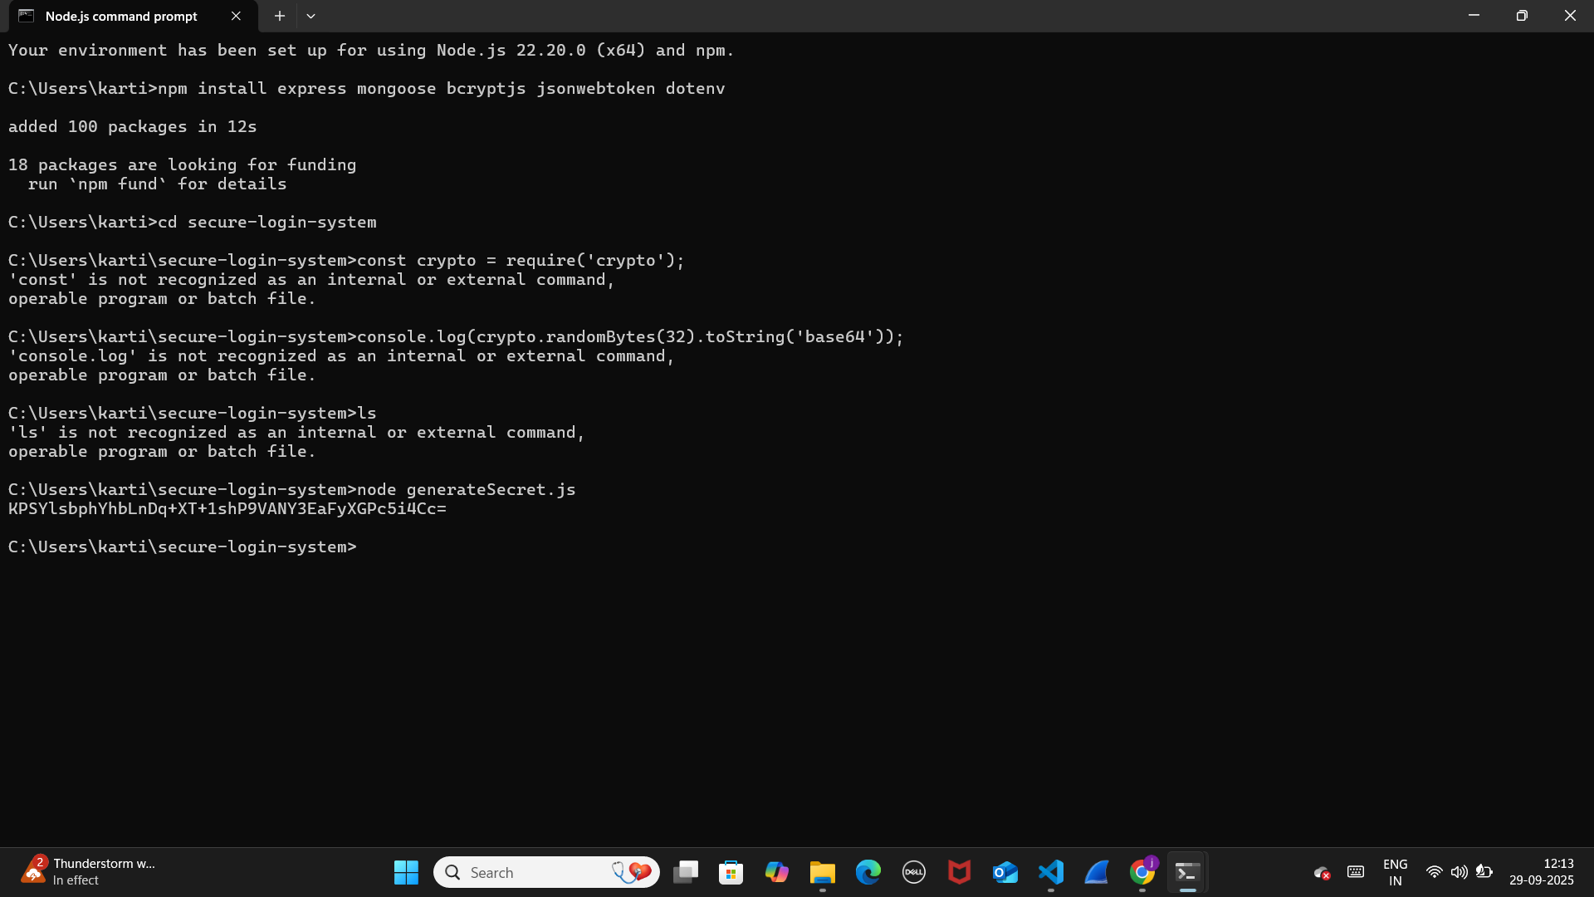

9.Connect the backend to a database (e.g., MySQL or MongoDB).

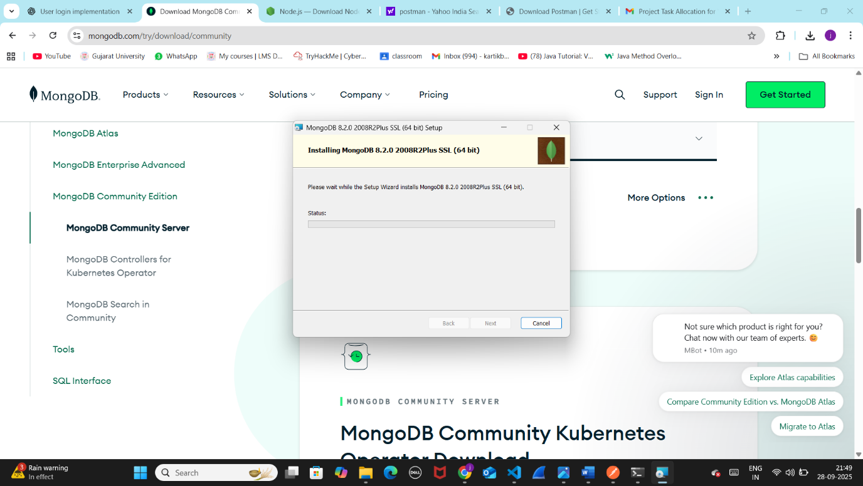



Create database tables/collections for storing user details, including roles.

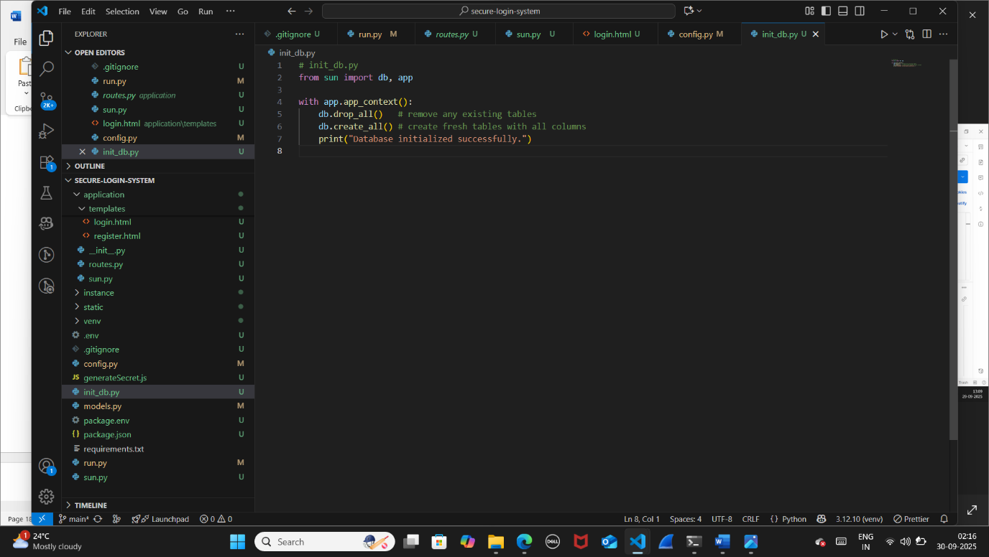

Day 4:

User Registration Implement user registration functionality. Hash passwords using secure algorithms like bcrypt or Argon2. Store user data securely in the database and test the registration process

**Flask (Python)**

1. **Install dependencies**

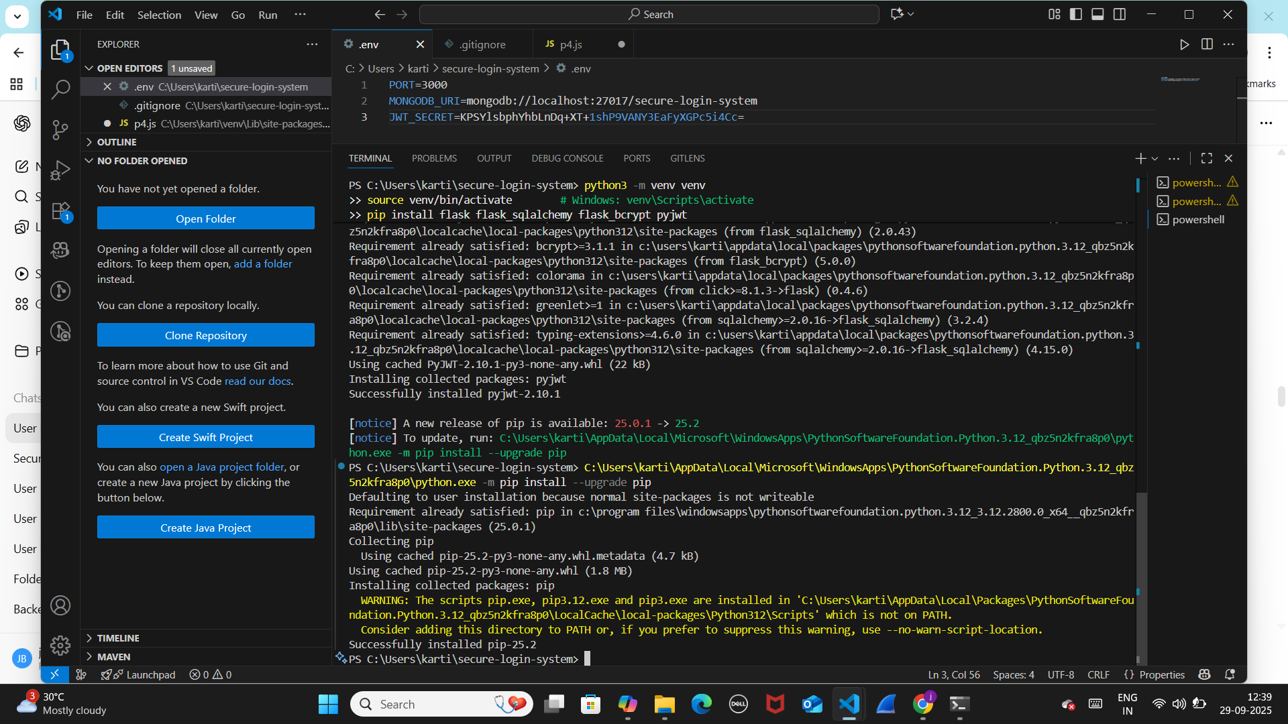

1. **Create Registration Route (run.py)**

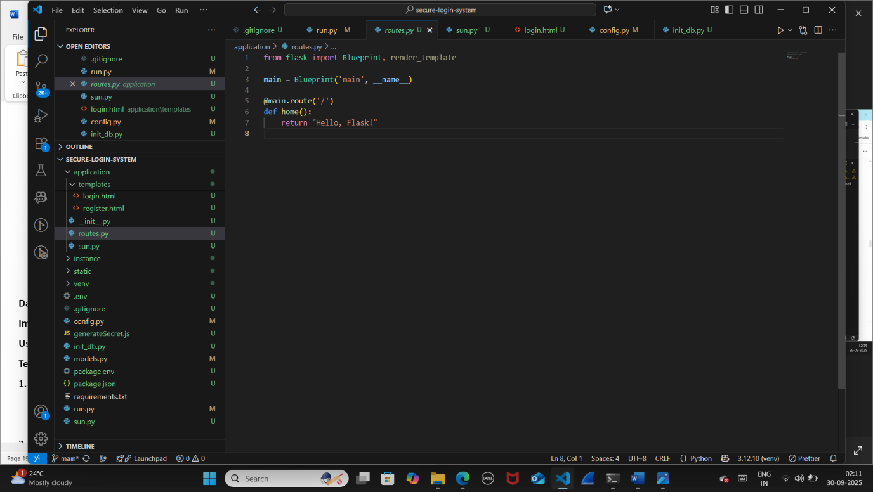

**3.Node.js (Express)**

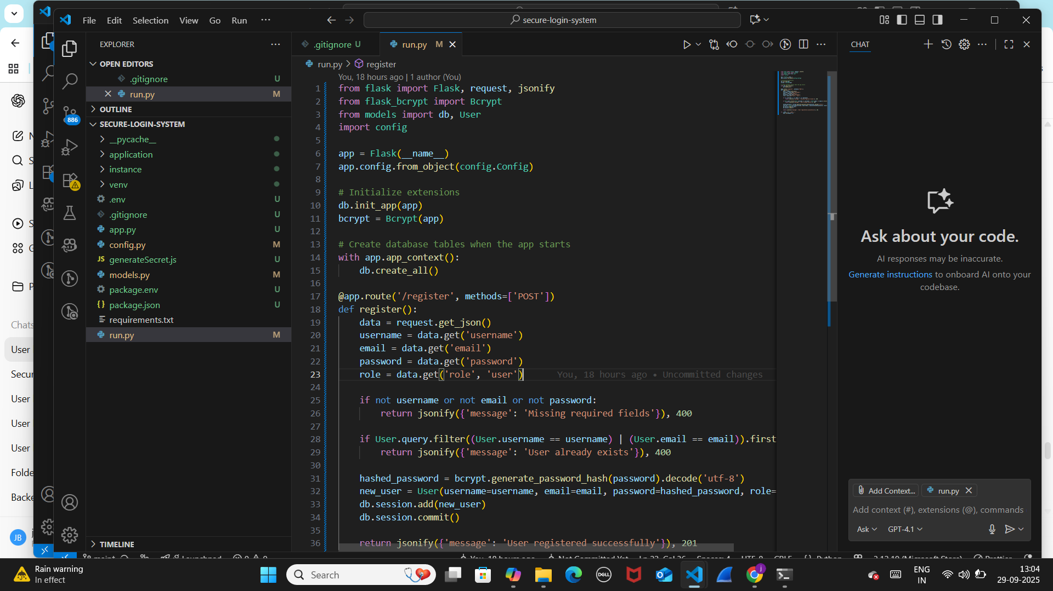

**4.Run your Flask server**

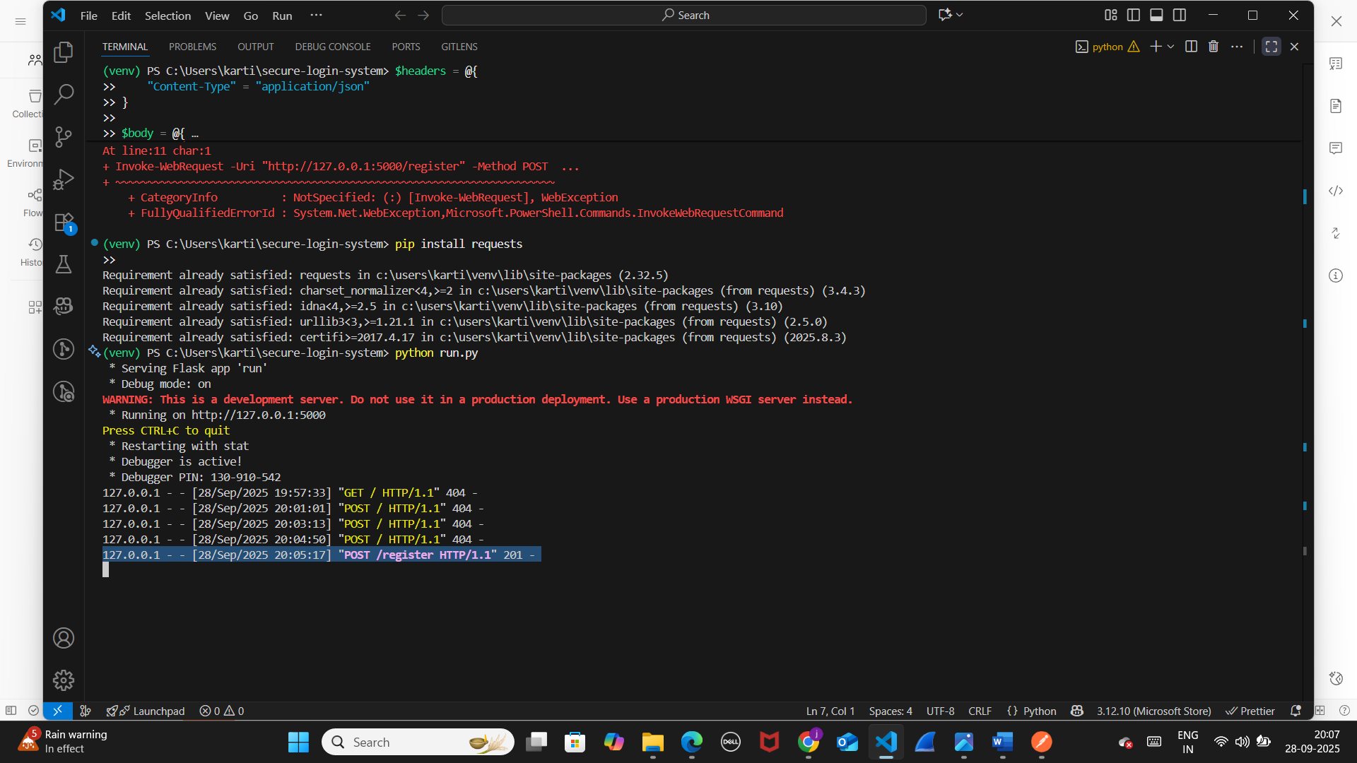

**Using Postman (GUI tool):**

**Registered admin and user-**

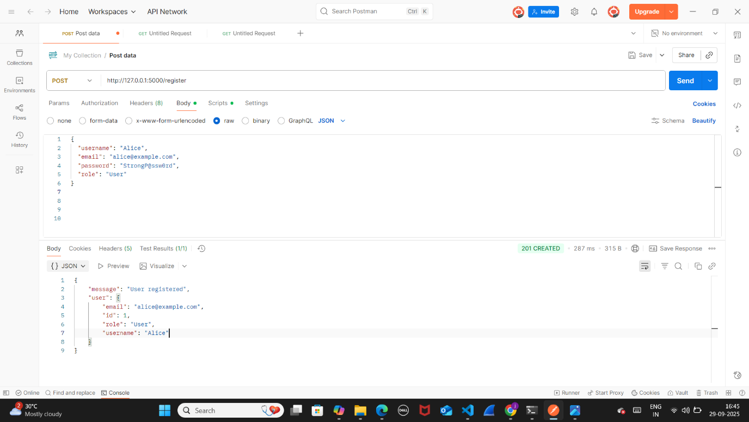

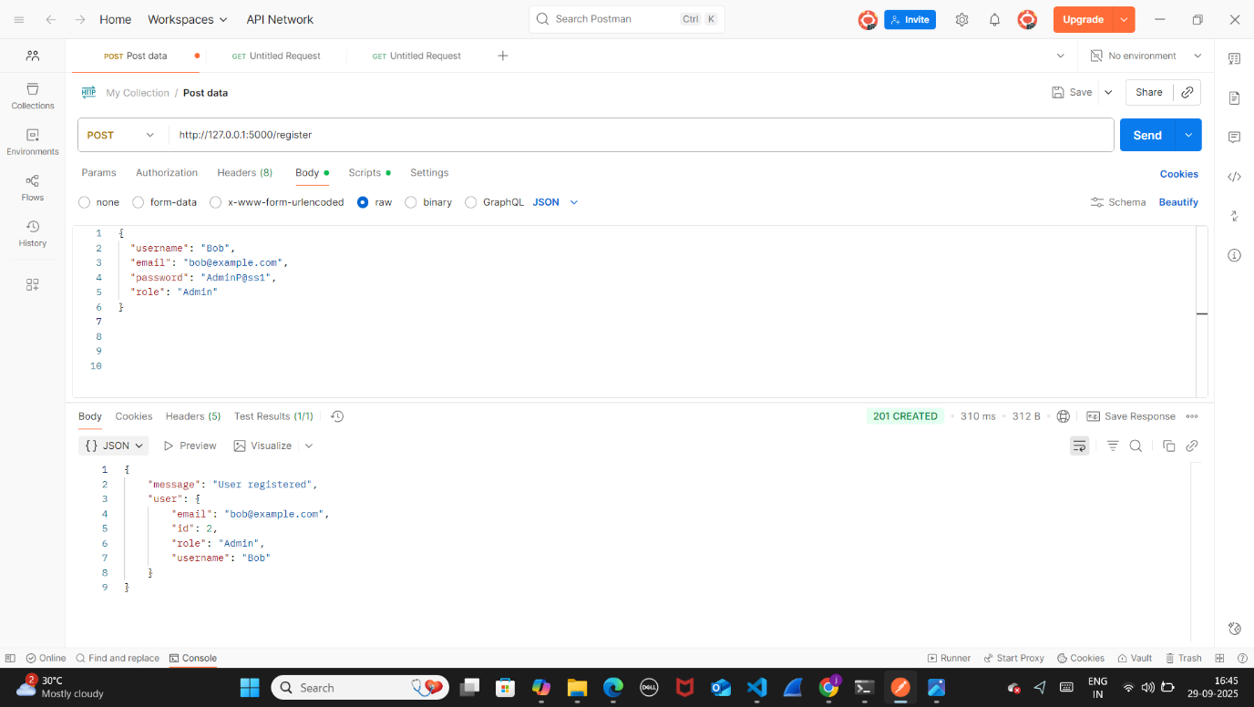

**Day 5: User Login**

**Implement user login functionality with email and password verification.**

**Use JWT (JSON Web Tokens) or session cookies for user sessions.**

**Test the login feature with both valid and invalid credentials.**

**1. Setup User Login Endpoint**

* **Create a /login route.**

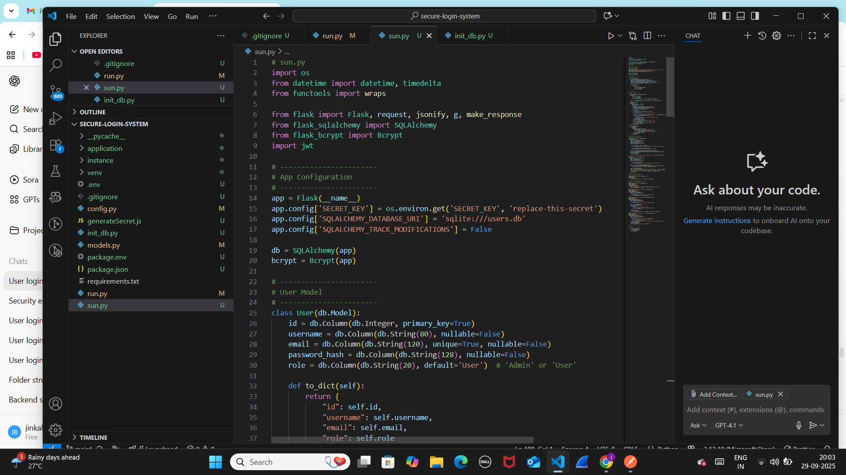

Through login session tokens are generated

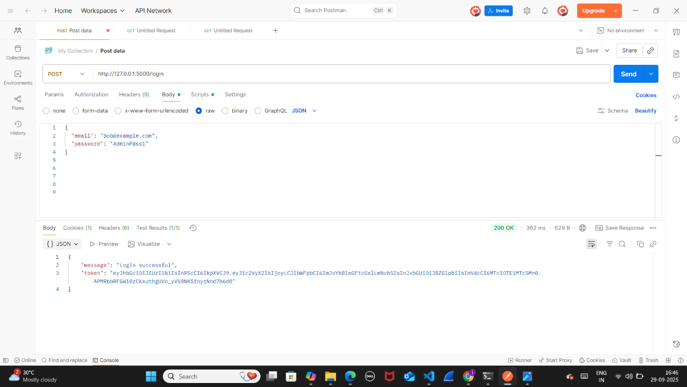

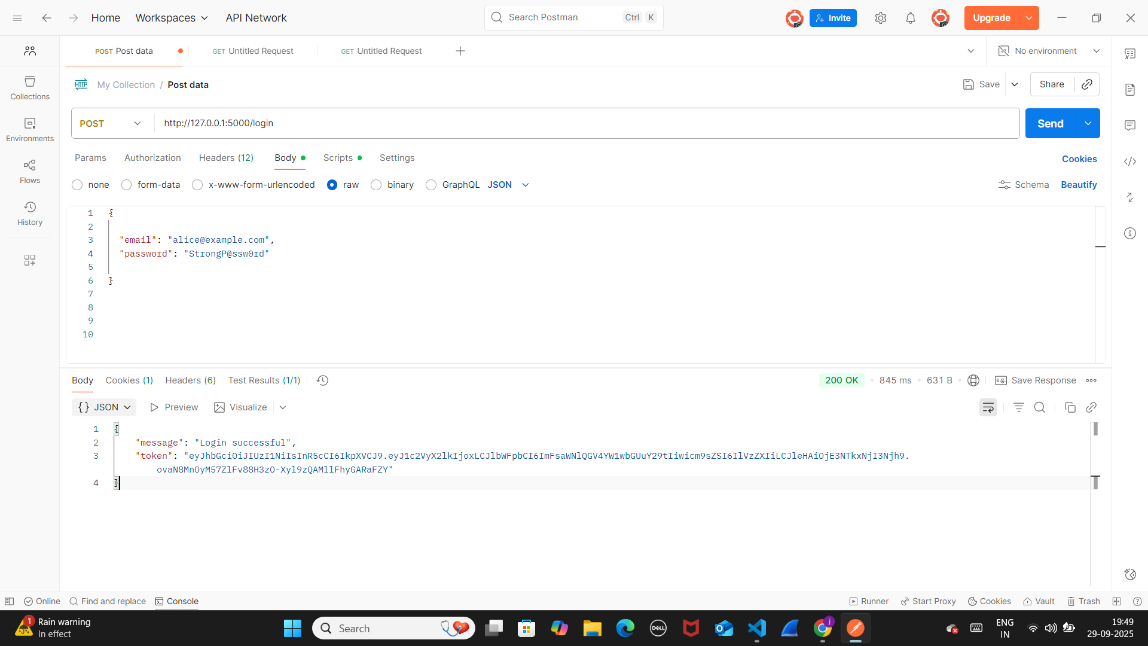

**2. Verify User Credentials**

* **Query the database for a user with the given email.**
* **Compare the provided password with the stored hashed password (use bcrypt or similar).**

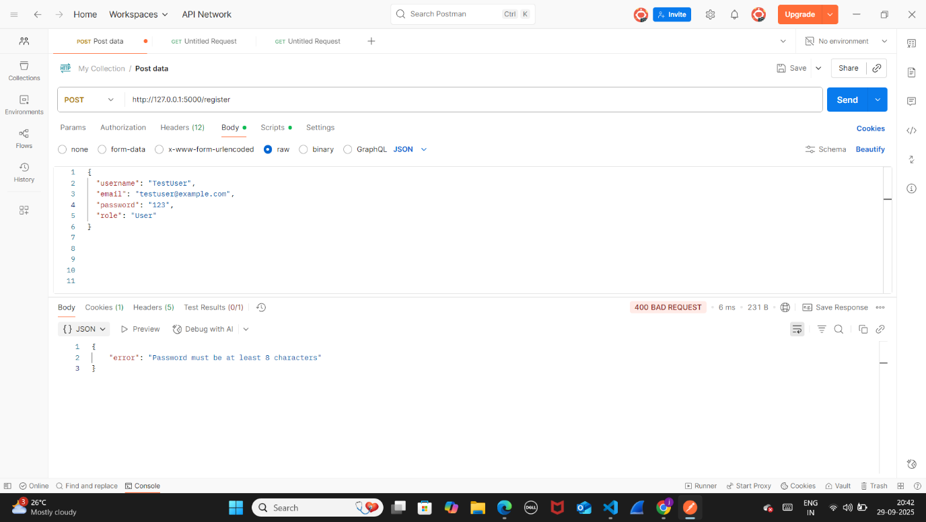

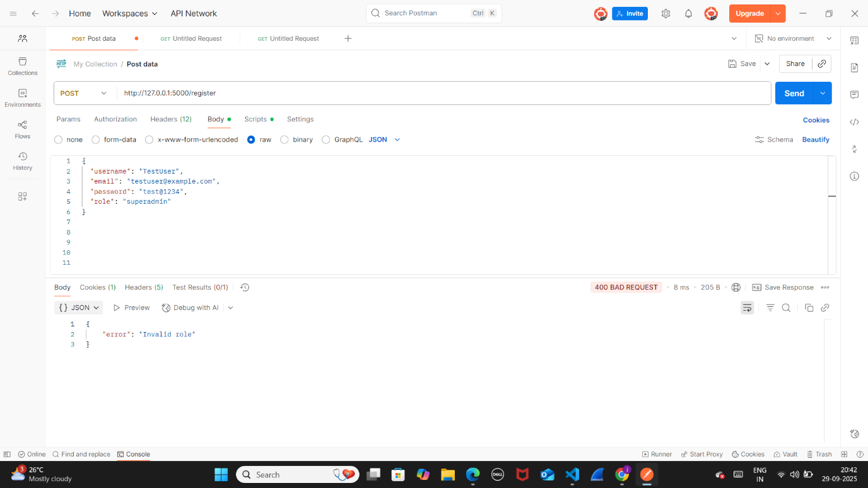

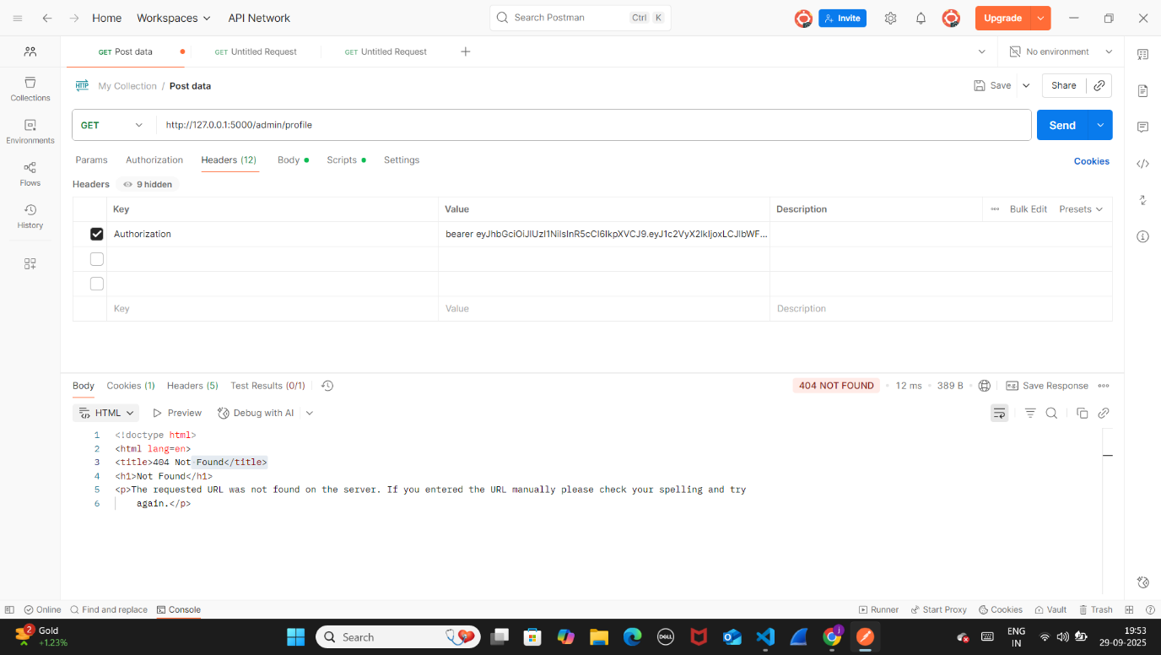

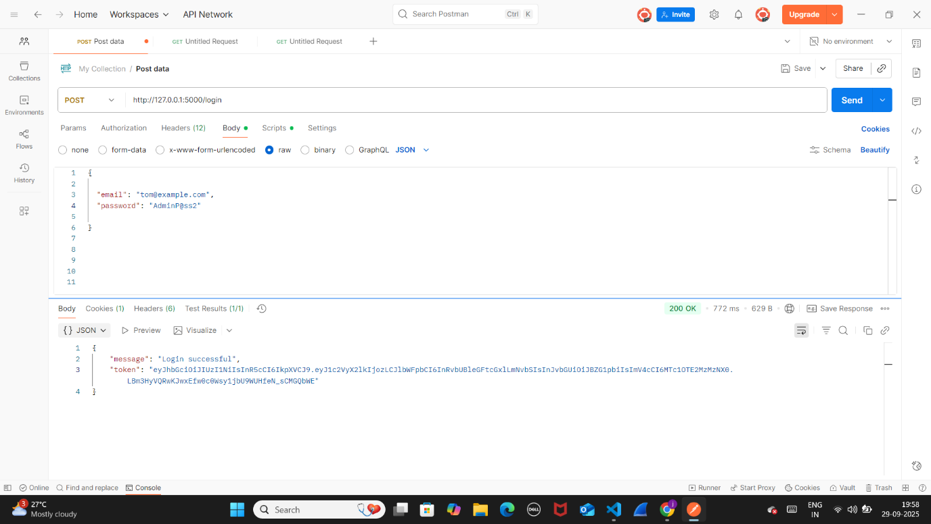

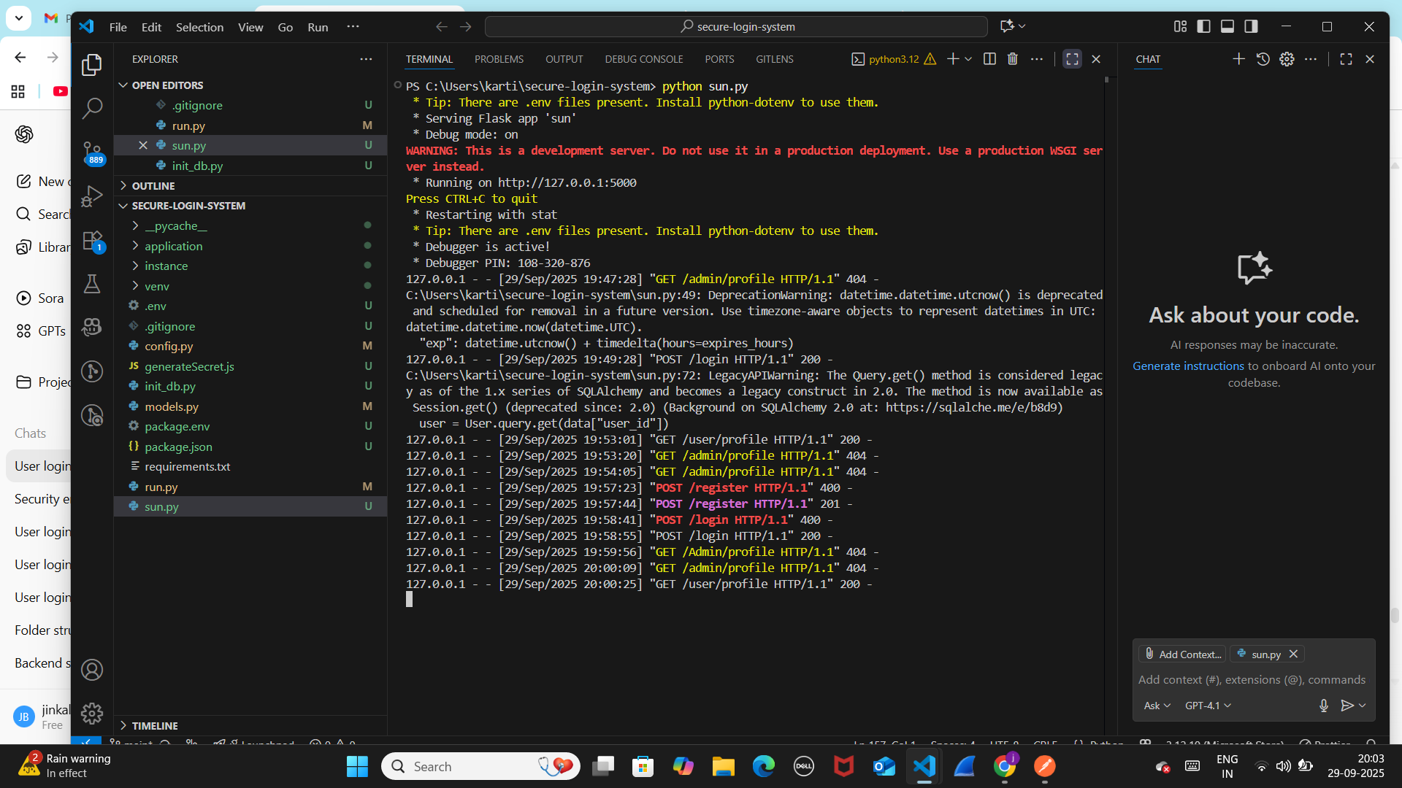

**Day 6:**

Role-Based Access Control (RBAC) Implement role-based access control for Admin and User roles. Create an Admin dashboard to view and manage all users. Restrict access to Admin functionalities for regular users.

1.Create sun.py



2.create admin.html file under static folder in the root project.

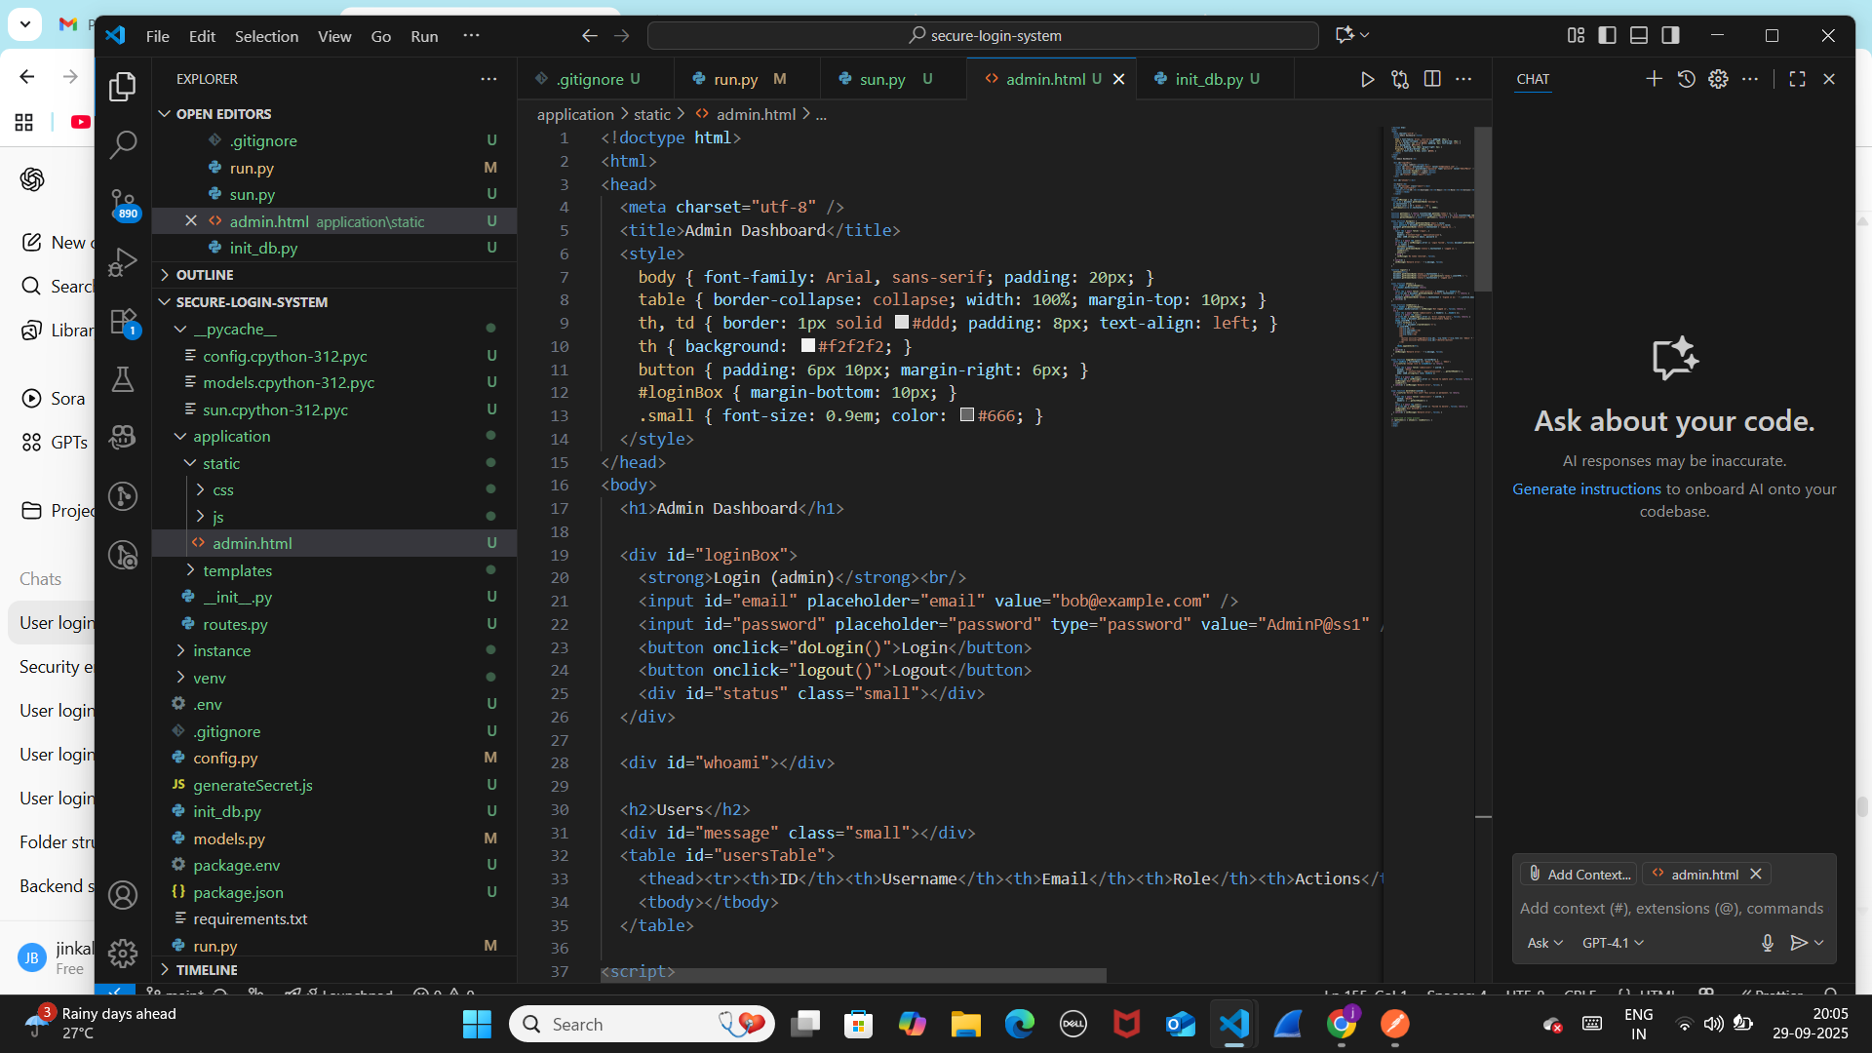

3.run the server

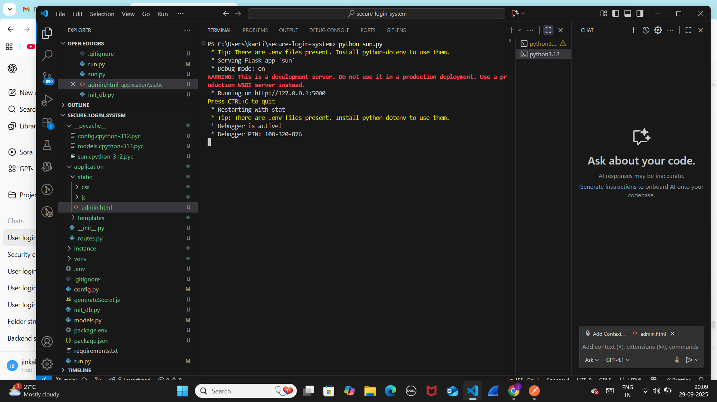

4.open <http://127.0.0.1:5000/static/admin.html> ---> admin can promte, demote or delete the users .

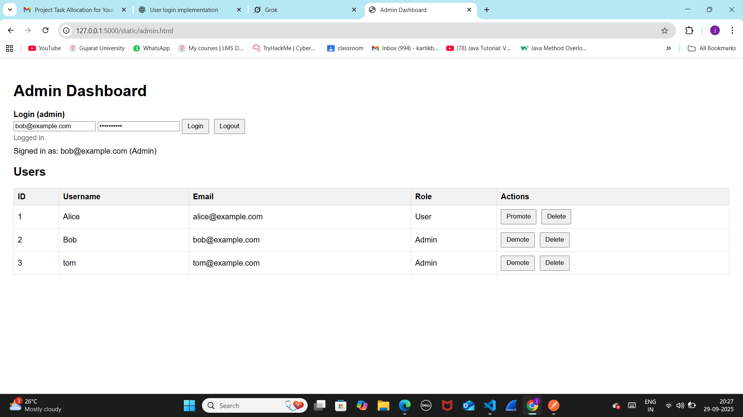

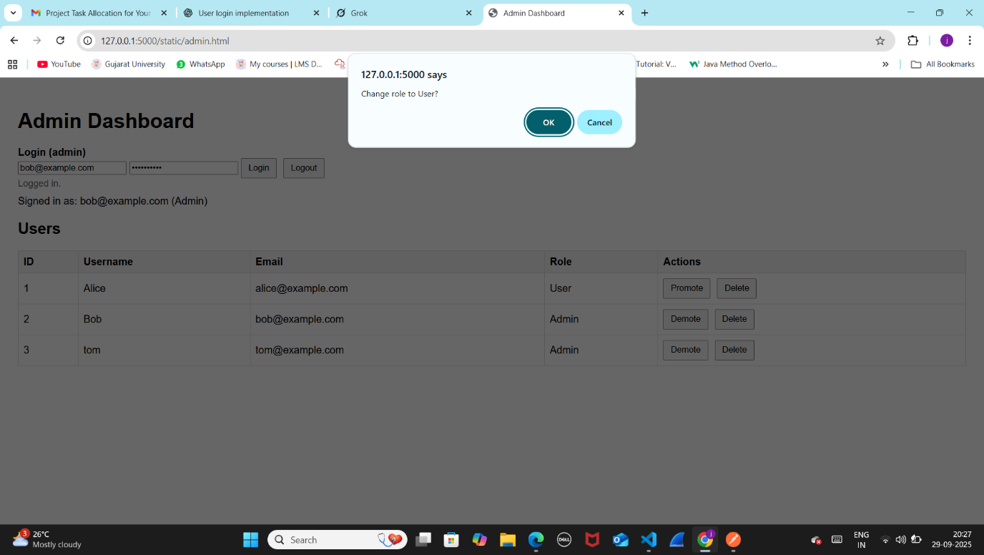

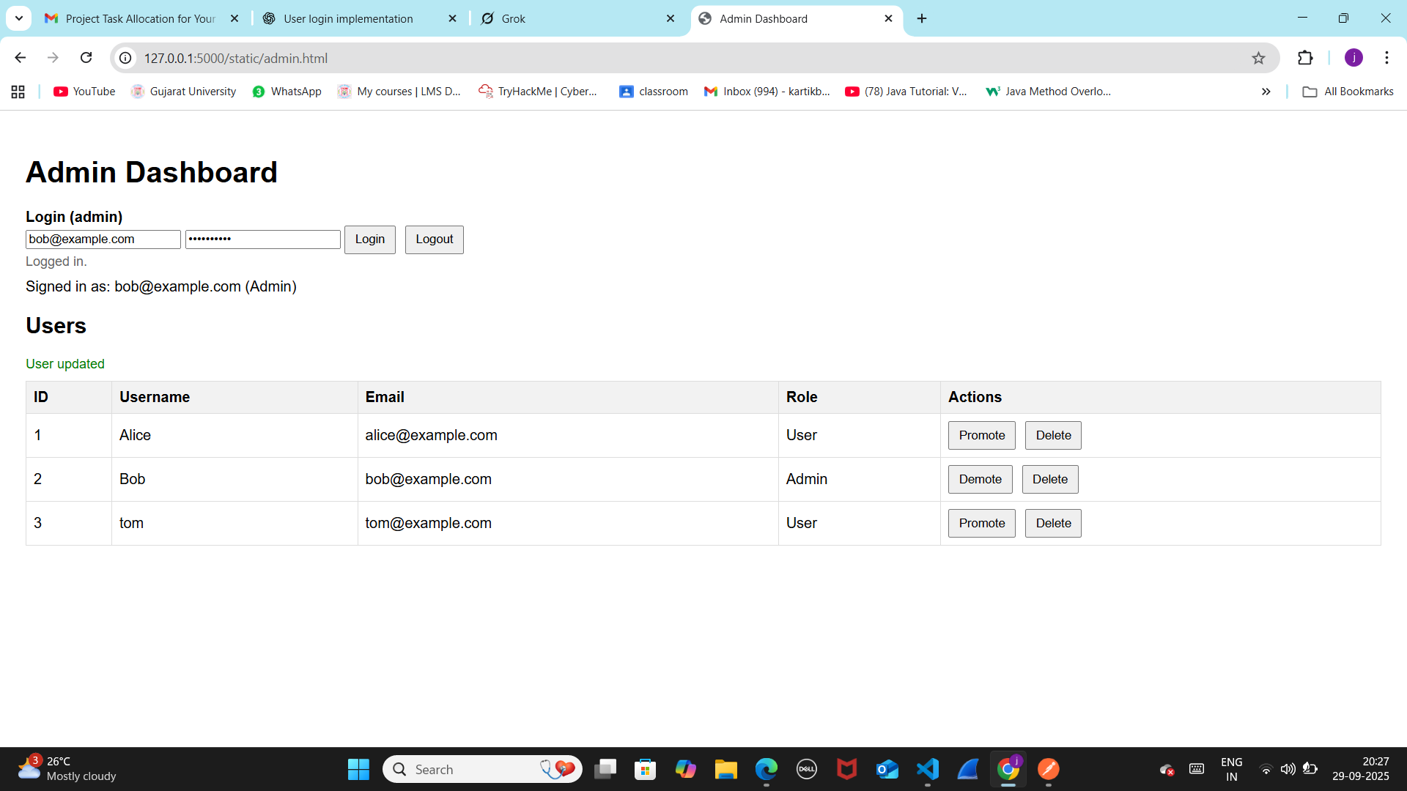

**Day 7: Security Enhancements**

* **Add input validation to prevent SQL Injection.**

By Day 3 (Backend Setup), the database was already created and connected:

* I already set up MongoDB (NoSQL database).
* I created the user table/collection with fields like:
  + id
  + username
  + email
  + password_hash
  + role (Admin/User)
  + created_at

So when I reach Day 7 (Security Enhancements), I don’t need to *create SQL again*

* **Implement CAPTCHA to protect against brute force attacks.**

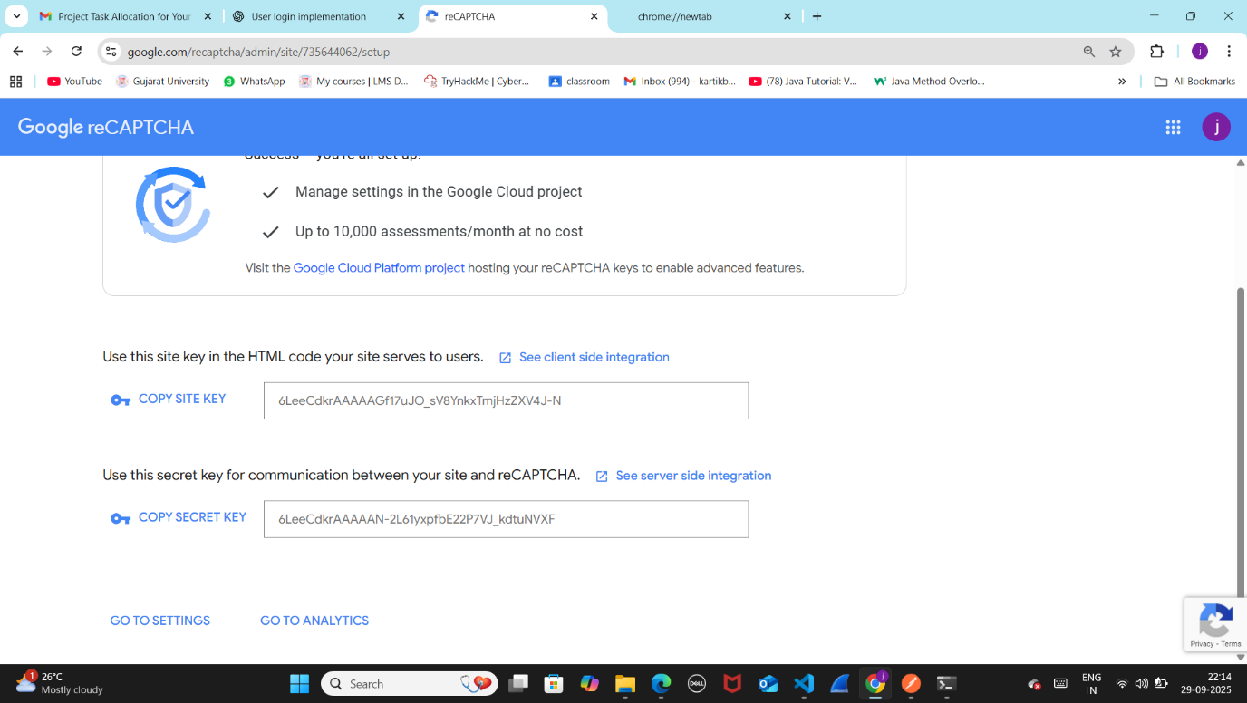

* **Set up account lockout after multiple failed login attempts.**

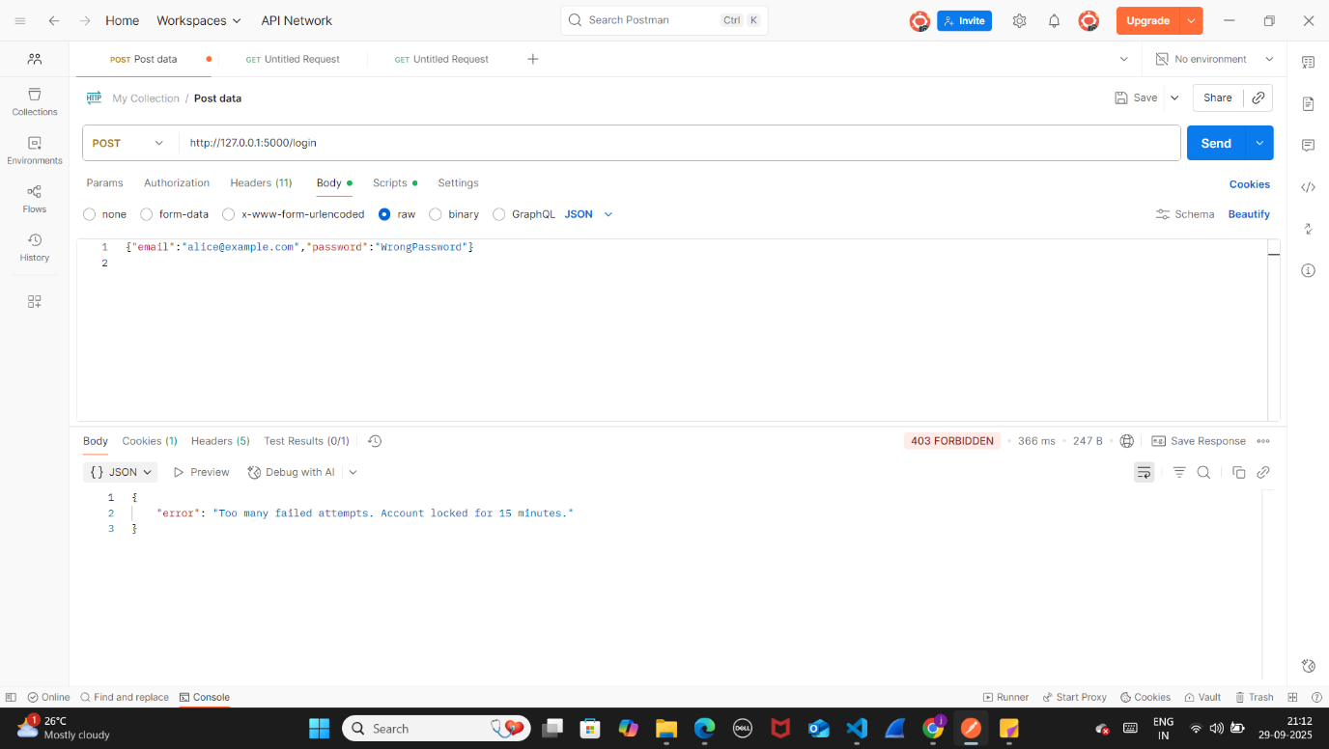

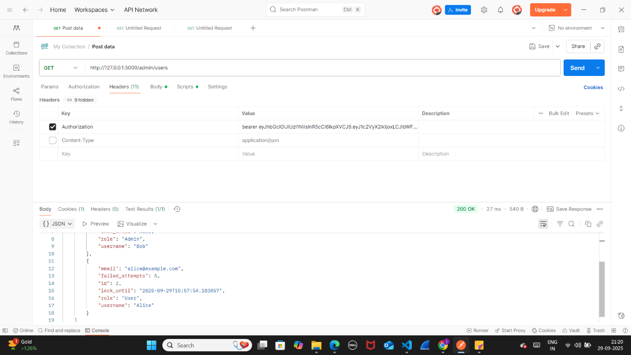

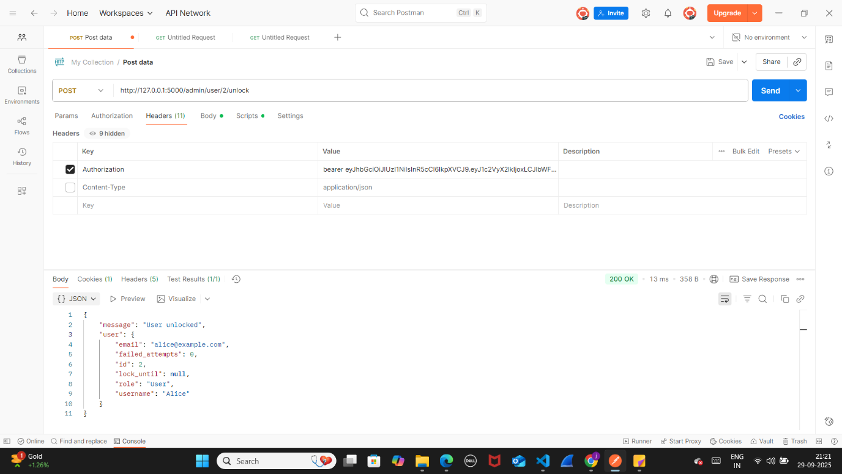

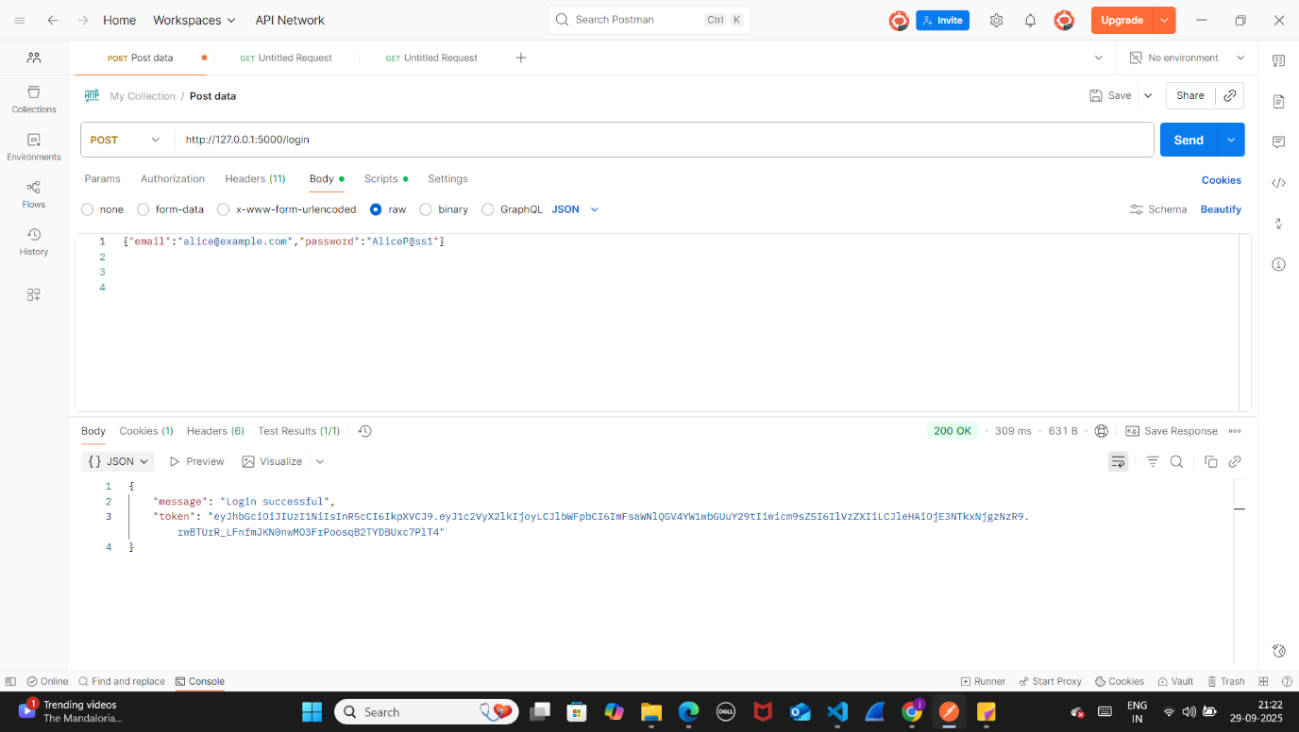

**Day 8: Testing and Debugging**

1.registration of different users-

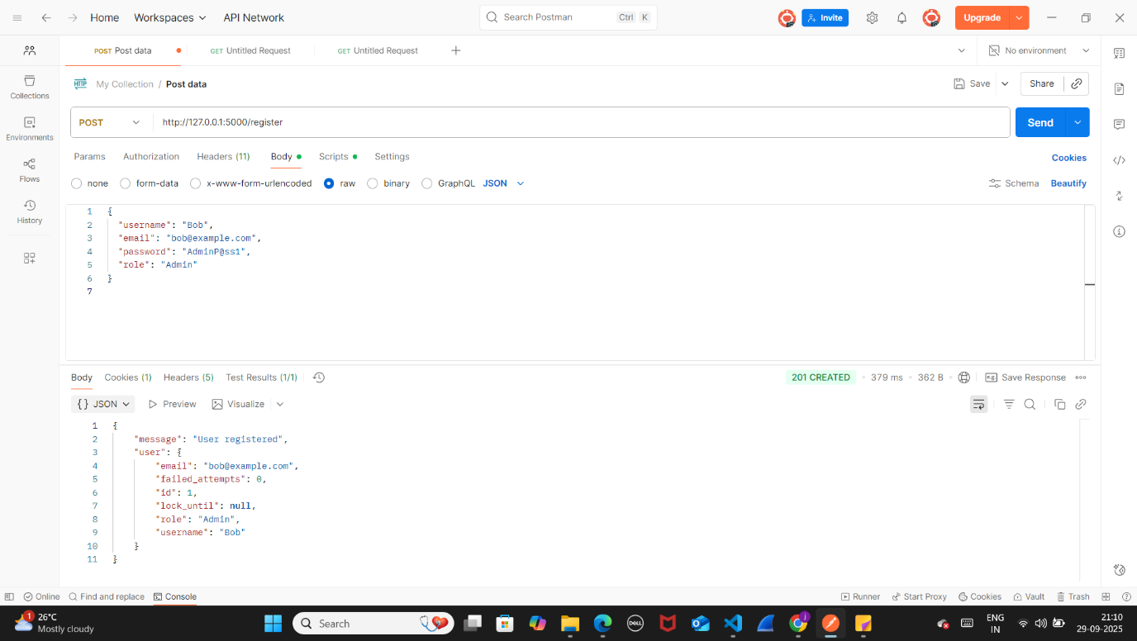

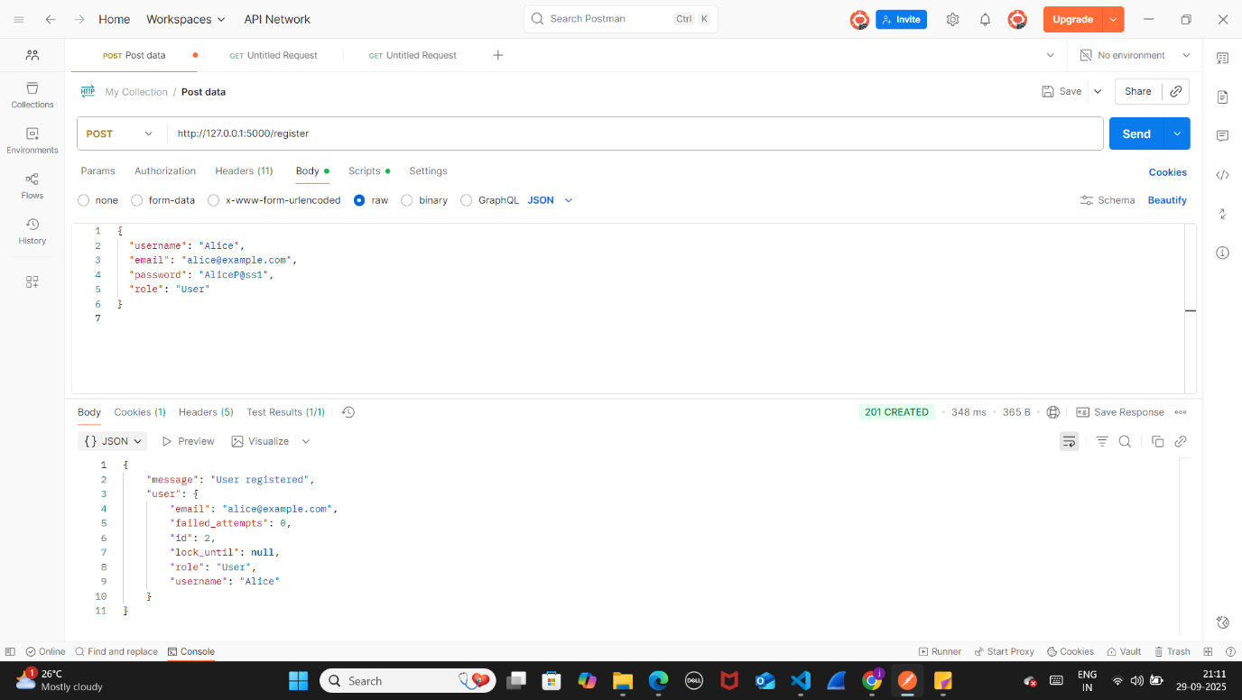

**2**.login process

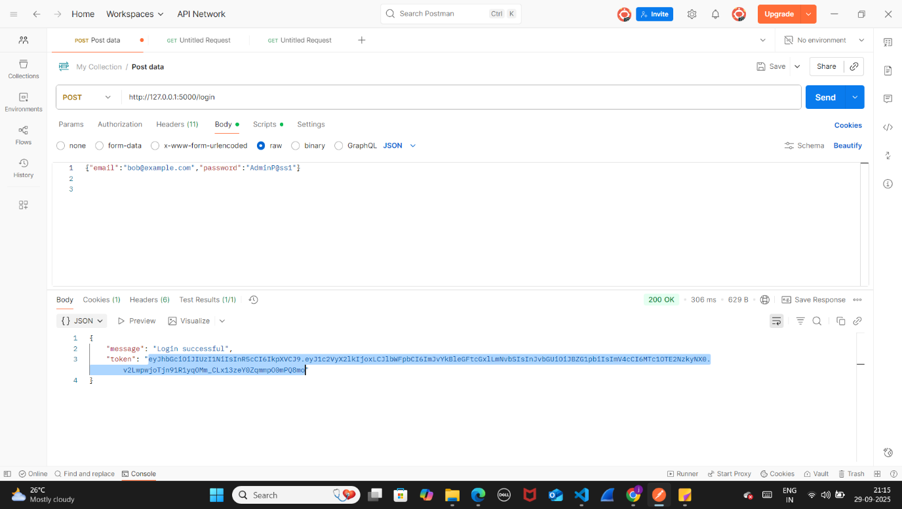

3.Debug issues and test for edge cases like duplicate registrations and invalid data.

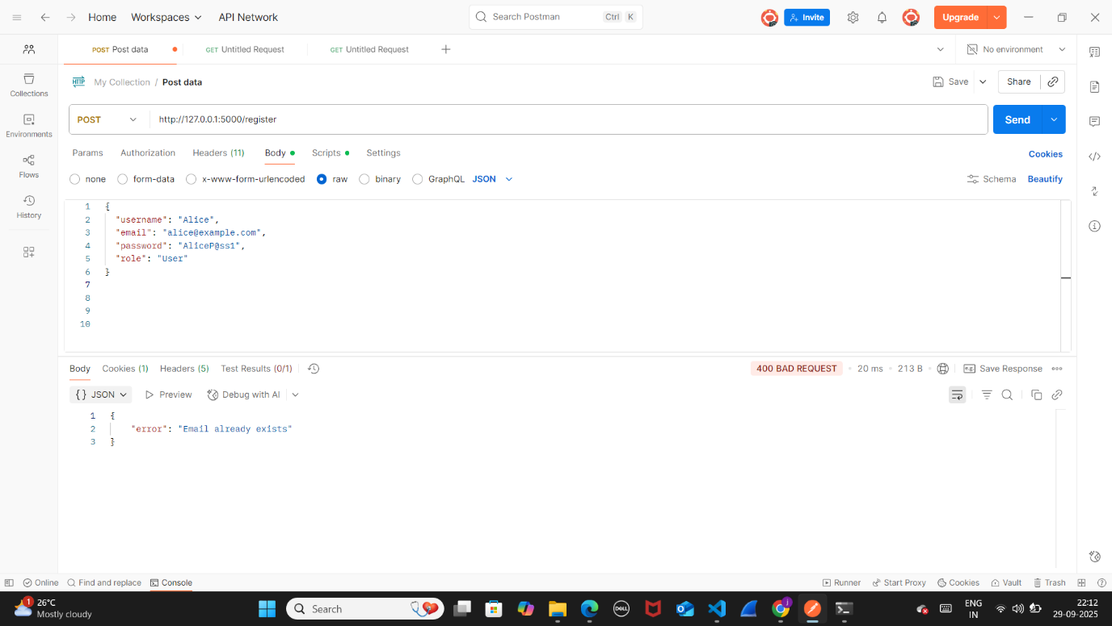

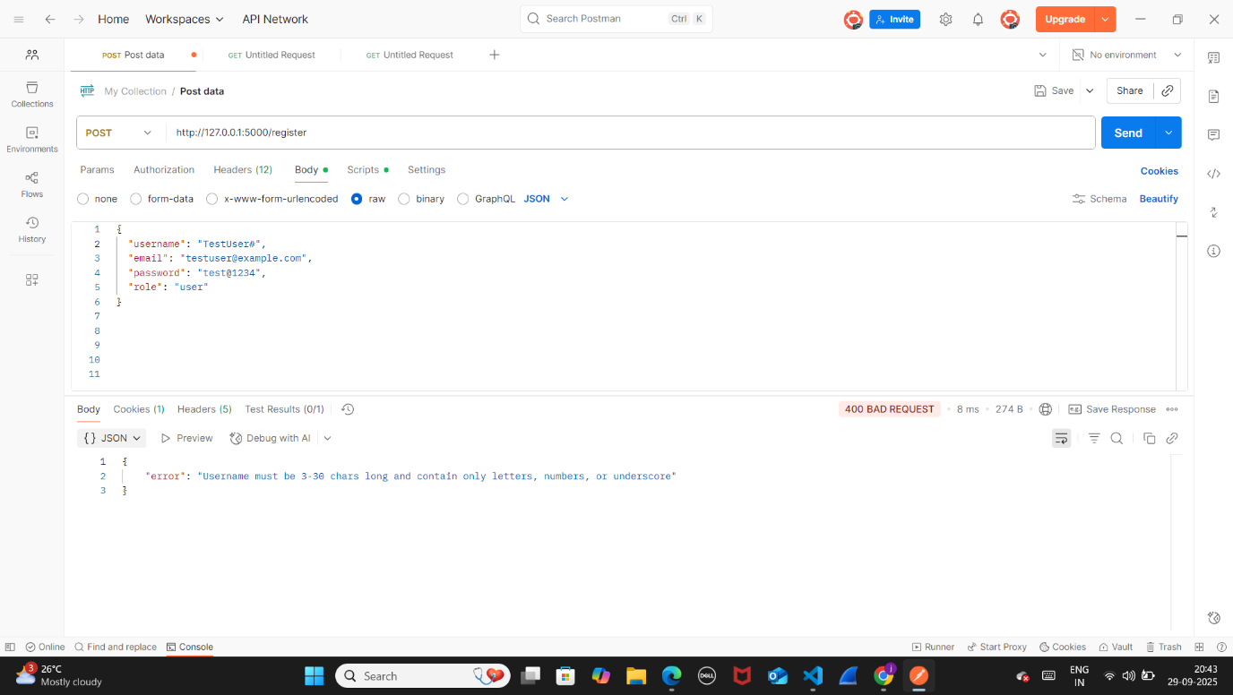





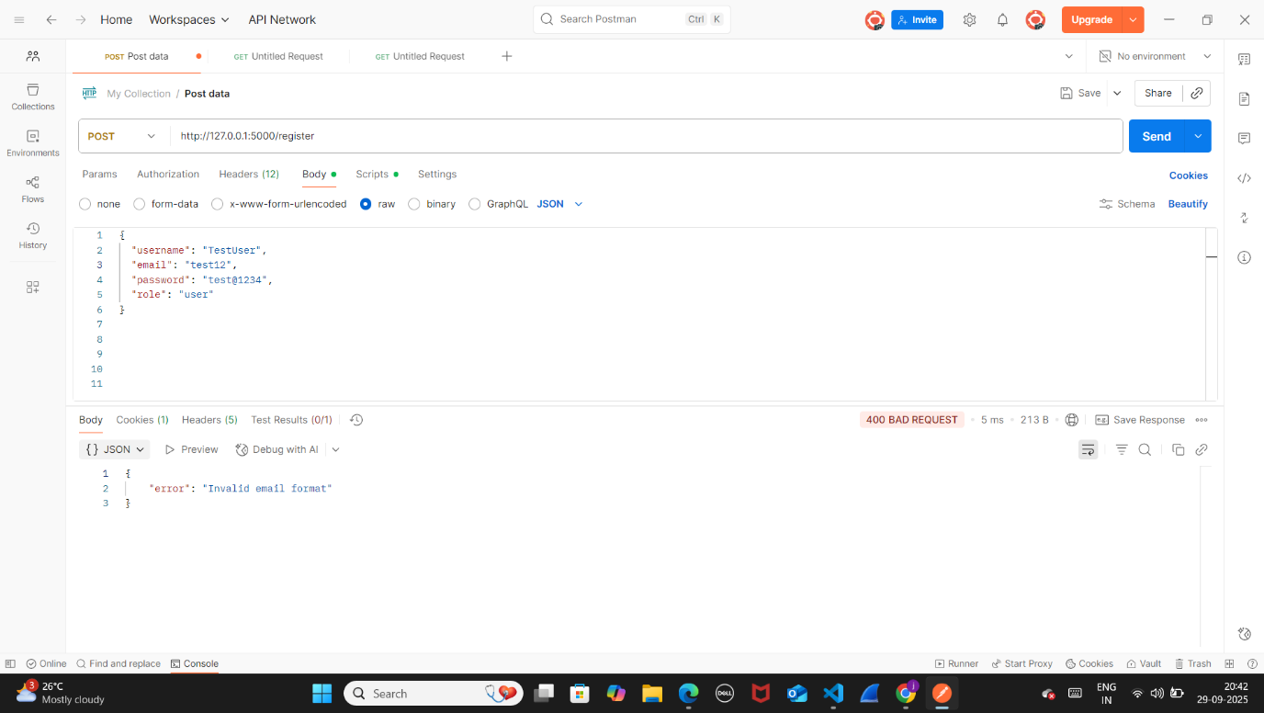

**Day 9: Documentation**

* **Create a README file in your GitHub repository with:**
  + **Project overview and setup instructions.**

Secure Login System with User Role Management

Project Overview

This project is a secure web-based login system that implements user authentication, authorization, and role-based access control (RBAC). It provides a practical way to apply cybersecurity concepts in a development environment.

Features

* User Registration & Login: Users can register and log in with secure credentials.
* Role-Based Access Control: Admins can manage users; regular users have restricted access.
* Security Features:
  + Password hashing using bcrypt
  + Input validation to prevent SQL injection
  + CAPTCHA verification (optional)
  + Account lockout after multiple failed login attempts

Technology Stack

* Backend: Python, Flask
* Database: SQLite (via SQLAlchemy ORM)
* Frontend: HTML, CSS
* Security: Bcrypt for password hashing, JWT for authentication

Setup Instructions

1. Clone Repository git clone cd secure-login-system
2. Create Virtual Environment python -m venv venv .\venv\Scripts\activate # Windows

source venv/bin/activate # macOS/Linux

1. Install Dependencies pip install -r requirements.txt
2. Set Environment Variables $env:ENABLE_CAPTCHA="1" $env:RECAPTCHA_SECRET="your_secret_here" $env:LOGIN_FAILED_LIMIT="5" $env:LOCK_TIME_MINUTES="15"
3. Initialize Database python init_db.py
4. Run Application python sun.py

Open [http://127.0.0.1:5000](http://127.0.0.1:5000/) in your browser.

**Document challenges faced and solutions implemented.**

| Challenge | Solution |
| --- | --- |
| Account lockout handling | Added failed_attempts and lock_until in database |
| Password security | Used bcrypt for hashing and verification |
| Role-based access control | Middleware to restrict access based on user roles |
| Brute force protection | CAPTCHA and account lockout implemented |
| Database errors | Re-created database with required columns |

Github README file link :

https://github.com/jinkal26/secure-login-system/blob/main/README.md

**Day 10: Final Submission**

**Github project link :**

Conclusion

Over the course of ten days, this project successfully implemented a secure login system with user authentication, role-based access control, and essential security features. Each day built upon the previous one, starting from environment setup and frontend design, to backend integration, database connectivity, secure registration and login, and finally, role-based dashboards with security enhancements.

The project not only strengthened practical development skills using Flask, SQLAlchemy, and JWT authentication, but also provided hands-on experience with fundamental cybersecurity concepts such as password hashing, input validation, and brute-force protection. By the end, a fully functional system was achieved that demonstrates both technical depth and secure coding practices.

Acknowledgement / Code of Thanks to vault-tech security

I would like to express my sincere gratitude to all those who supported and encouraged me throughout the duration of this project.

* Mentors/Guides — for their valuable advice and continuous guidance.
* Peers/Team Members — for collaborative learning, testing, and providing constructive feedback.
* Community Resources — including open-source documentation, forums, and tutorials that provided useful insights.

Their support was instrumental in helping me complete this project on time and with quality.

Closing Remarks

This 10-day journey has been both challenging and rewarding. I was able to translate theoretical knowledge into practical implementation, reinforce cybersecurity best practices, and build confidence in managing real-world development tasks. The Secure Login System stands as a foundation for future enhancements, such as multi-factor authentication, advanced logging, and deployment in cloud environments.

This project marks not just the completion of a task, but the beginning of continuous learning and improvement in secure software development.